Monday |  |  |  | Tuesday |  | Wednesday |  |  |  |  | Thursday |  |  |  |  | Friday |  |  |  |  |  | Saturday |  |  |  | Sunday
How to use this month's calendar!  Either - do these tasks each night...little and often as these are very small ‘chunks’ of knowledge  Or - do a week's worth in one go.  The marks next to it indicate how long you would have to answer the question in a timed exam. You need to take a bit more time as you are revising and going over the topic in prep for your mocks. |  |  |  |  |  |  |  |  |  |  | 1st  Name and define the four types of erosion (4) CASH Corrasion |  |  |  |  | 2nd  Explain the process happening here (4)  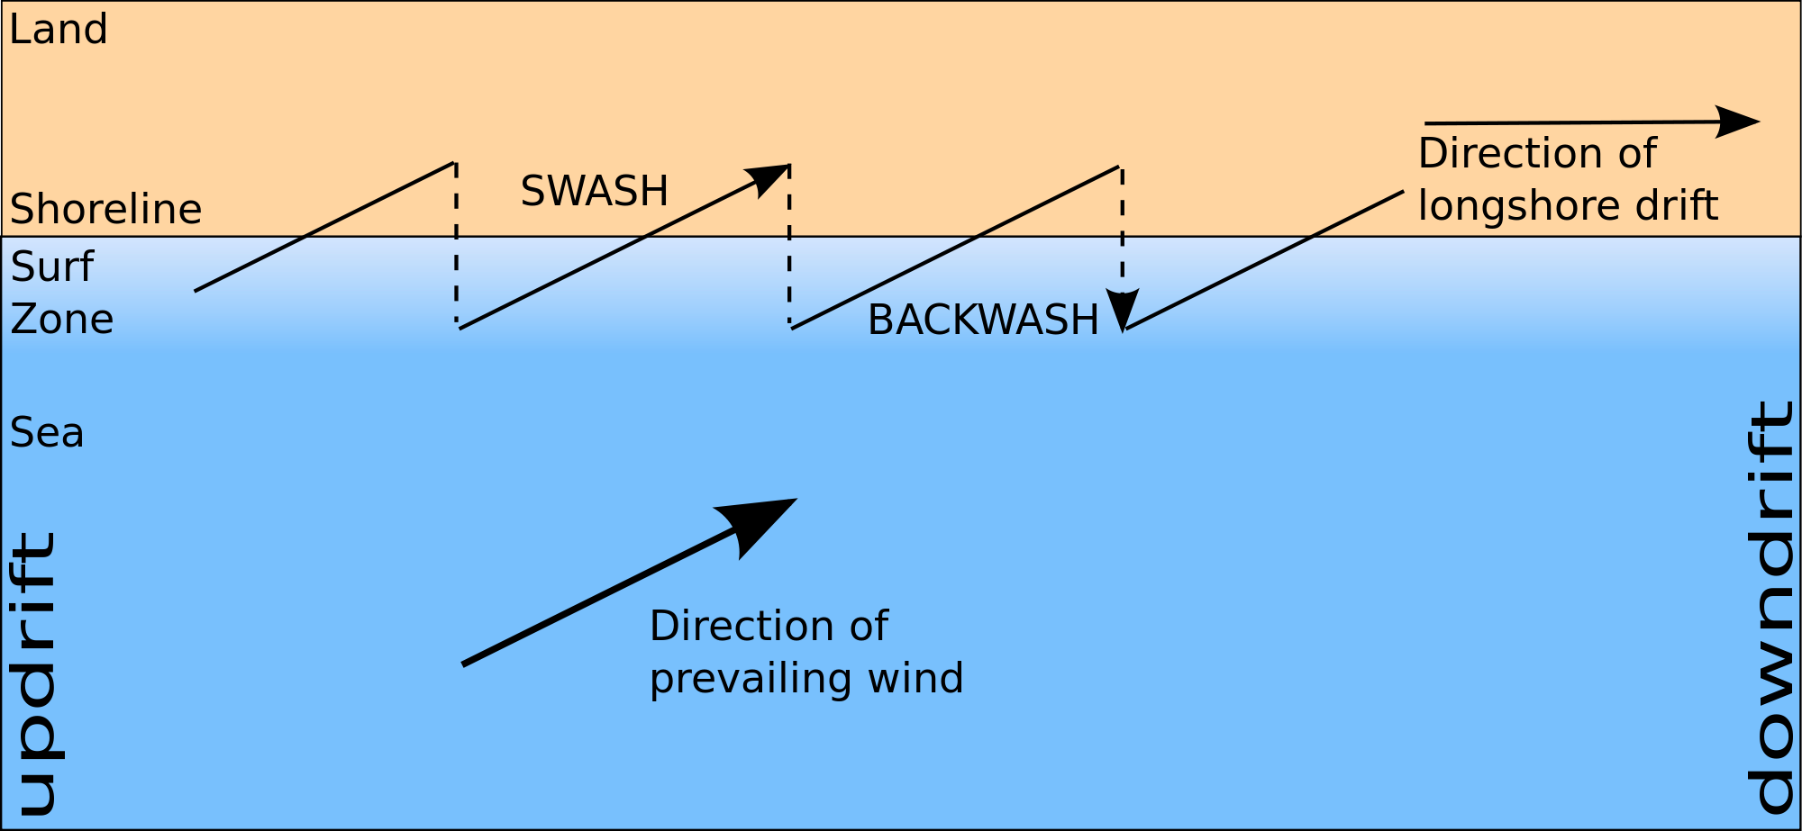 |  |  |  |  |  | 3rd  How does geology affect rates of erosion along the coast? (4) |  |  |  | 4th  Make some notes on the coastline we studied - Old Harry Rocks, Hengistbury Head and Mudeford Spit
5th  Explain how hard engineering is used to protect coastal areas from the effects of storm waves and wave attack. (4) |  |  |  | 6th  What is the difference between weathering and erosion? (2) |  | 7th  Explain how this landform was formed (2)  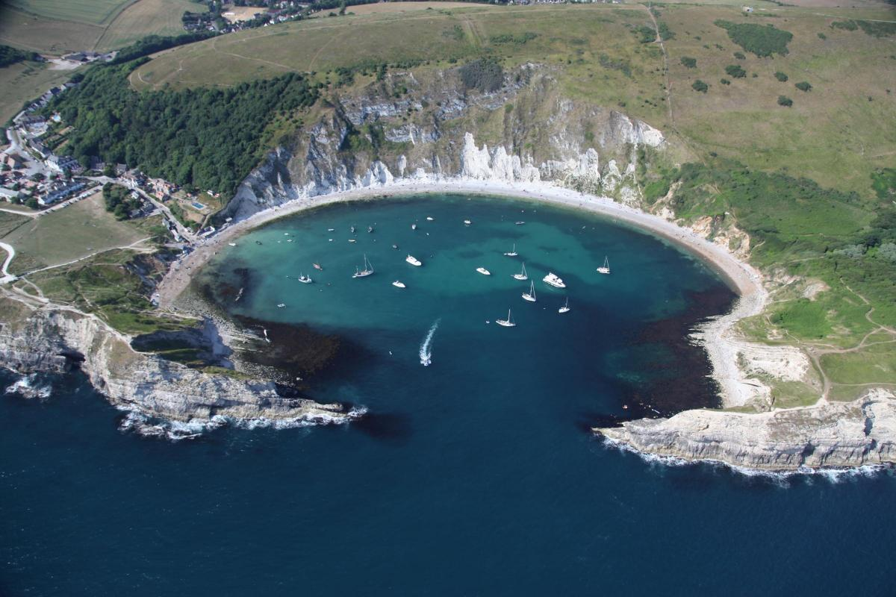 |  |  |  |  | 8th  Go on the OS website and complete the rivers tasks:  https://www.ordnancesurvey.co.uk/mapzone/geography |  |  |  |  | 9th  Make a table of the costs and benefits of hard engineering to control river flooding (4) |  |  |  |  |  | 10th  Describe how river processes of transportation and deposition change downstream. (4) |  |  |  | 11th  Describe and explain how human development damages the coastline. (4)
12th  To what extent do you agree with this statement?  ‘River flooding is a natural phenomenon.’ (9) |  |  |  | 13th  Explain the formation of a meander (4) |  | 14th  Describe how soft engineering methods are used to protect coastal areas. (2) |  |  |  |  | 15th  What are the differences between constructive and destructive waves? (2) |  |  |  |  | 16th  Name & describe the 4 types of transportation of sediment & material in a river (4) |  |  |  |  |  | 17th  Explain the formation of caves, arches and stacks (4) |  |  |  | 18th  Draw and annotate a diagram to show the difference between concordant and discordant coastlines (4)
19th  Explain the formation of levées. (2) |  |  |  | 20th  What is mass movement? (2) |  | 21st  Describe how the long profile of a river valley changes downstream. (2) |  |  |  |  | 22nd  What factors affect the processes operating along a stretch of coastline? (4) |  |  |  |  | 23rd  Make case study notes on Boscastle flood and management 2004 |  |  |  |  |  | 24th  Outline one physical cause of flooding. (2) |  |  |  | 25th  Complete your knowledge organiser on rivers
26th  What is a hydrograph? What is lag time? (2) |  |  |  | 27th  Listen to Mrs Broadribb’s podcast about coastal erosion on Spotify/apple music |  | 28th  Complete your knowledge organiser for coasts |  |  |  |  | 29th  Use a named example to describe and explain responses to river flooding (6) |  |  |  |  | 30th  Explain the factors affecting river discharge (4) |  |  |  |  |  | 31st  Explain how a spit is formed? (4) |  |  |  | The knowledge organisers will be given to you and will be collected in and checked by your teacher

