#### Karen Falcon

#### April 2021

#### Final version

#### © Hampshire County Council

### What is geography?

#### A guide to the discipline of geography.

# HIAS MOODLE+ RESOURCE

## Overview

**This document contains…**

A guide to the discipline of geography.

**Points to consider when using this resource**

There are many techniques, strategies and approaches that can be used to bring the themes to life.

**What is geography?**

**What is the discipline of geography?**

National Geographic state, “Geography is the study of places and the relationships between people and their environments. Geographers explore both the physical properties of Earth’s surface and the human societies spread across it. They also examine how human culture interacts with the natural environment, and the way that locations and places can have an impact on people. Geography seeks to understand where things are found, why they are there, and how they develop and change over time”. Geography is the only subject where you can study for a BSc and a BA at university and is where all pupils can connect to their immediate, national, and global world.

**How can we get the best out of our pupils?**

The content of the subject is best learnt when it is connected to pupils as almost every aspect can be found locally and globally. Pupils are at the centre of a world that is changing rapidly as well as staying reassuringly consistent and geography helps them make sense of changes past, present and in the future.

Geography is comprised of knowledge, understanding, and skills and these areas need to be skilfully interwoven in planning to give pupils the opportunity to learn as a geographer using the skills of a geographer. A geography lesson, or sequence of lessons, should be a combination of a MFL, maths, English, science, and PE. It should be brought to life through the eyes of the pupil, as modelled by the teacher, so pupils learn how to look as a geographer. We look at things from our perspective and we need to teach our pupils the disciplinary eye and make sure they have them in for each geography lesson and ideally when they leave our lesson!

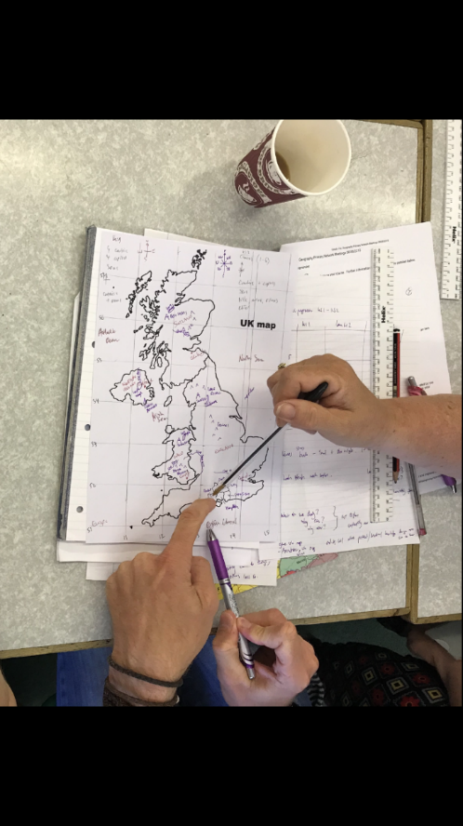Geography is a very visual subject, and every exam has a range of resources or figures that pupils must refer to in their answers. Consequently, pupils must be fluent in looking at a range of resources including tables, maps, graphs, images, extracts, and infographics. Pupils must be able to identify features of the resource and link it to their knowledge and understanding. They need to be able to retrieve their knowledge and understanding when presented with unfamiliar resources in the exam and this means that lessons should have a variety of visuals for pupils to interact with.

Geography is also a practical subject and fieldwork is a unique element of the subject, yet it can be hard to locate in planning. Fieldwork can utilise the school grounds and for pupils to experience the subject as it is in real life, they need to become independent in the process of fieldwork. Fieldwork opportunities allow all pupils to access geography content and experience global concepts in a local context which is so important for learning. Connecting new knowledge to prior knowledge is key to successful learning and adding in an experience helps add a deep trace to information in long term memory. The deeper the trace and the more routes to connect back to the information the greater the chance of retrieval.

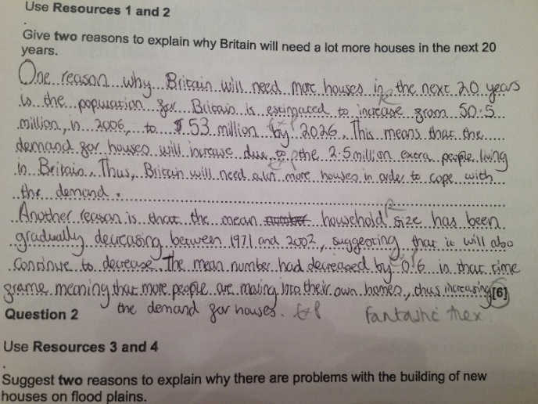To support retrieval geographers, need to become fluent in geography! Every subject has a unique disciplinary literacy and exploration and explicit teaching of this is key to supporting all pupils succeed in geography. Geography has its fair share of tier 3 words and it is the tier 2 words that can be a barrier for pupils in the exams. The longer answer questions often have a tier 2 word which is the crux of the question upon which the evaluation or analysis hinges. Inaccurate identification and understanding of this tier 2 word results in an explanation rather than an evaluation and lower attainment. The MFL and English element is present in every geography lesson in a way that the maths element may occur once in every sequence of lessons. The Education Endowment Foundation has useful guidance on disciplinary literacy and the link to the full document and poster is below.

[EEF_KS3_KS4_LITERACY_GUIDANCE.pdf (educationendowmentfoundation.org.uk)](https://educationendowmentfoundation.org.uk/public/files/Publications/Literacy/EEF_KS3_KS4_LITERACY_GUIDANCE.pdf)

<https://educationendowmentfoundation.org.uk/public/files/Publications/Literacy/EEF_KS3_KS4_LITERACY_GUIDANCE.pdf>

**Karen Falcon - Geography Team**

Karen.Falcon@hants.gov.uk

For further details on the full range of services available please contact us using the following details:

Tel: 01962 874820 or email: [hias.enquiries@hants.gov.uk](mailto:hias.enquiries@hants.gov.uk)

**Upcoming Courses**

Keep up-to-date with our learning opportunities for each subject through our Upcoming Course pages linked below. To browse the full catalogue of learning offers, visit our new Learning Zone. Full details of how to access the site to make a booking are provided [here](https://hias-moodle.mylearningapp.com/mod/page/view.php?id=481).

* [English](https://english.hias.hants.gov.uk/course/view.php?id=522)
* [Maths](https://maths.hias.hants.gov.uk/course/view.php?id=218)
* [Science](https://science.hias.hants.gov.uk/course/view.php?id=155)
* [Geography](https://geography.hias.hants.gov.uk/course/view.php?id=131)
* [RE](https://re.hias.hants.gov.uk/course/view.php?id=118)
* [History](https://history.hias.hants.gov.uk/course/view.php?id=91)
* [Leadership](https://leadership.hias.hants.gov.uk/course/view.php?id=144)
* [Computing](https://computing.hias.hants.gov.uk/course/view.php?id=43)
* [Art](https://art.hias.hants.gov.uk/course/view.php?id=35)
* [D&T](https://designandtechnology.hias.hants.gov.uk/course/view.php?id=36#section-0)
* [Assessment](https://languages.hias.hants.gov.uk/course/view.php?id=20)
* [Support Staff](https://hias-moodle.mylearningapp.com/course/view.php?id=82)
* [SEN](https://sen.hias.hants.gov.uk/course/view.php?id=5)

**Terms and conditions**

**Terms of licence**

Moodle+ subscribers are licenced to access and use this resource and have agreed to pay the annual subscription fee. This authority starts when the fee is paid and ends when the subscription period expired unless it is renewed. This file is for personal or classroom use only. By using it, you agree that you will not copy or reproduce this file except for your own personal, non-commercial use. HIAS have the right to modify the terms of this agreement at any time; the modification will be effective immediately and shall replace all prior agreements.

**You are welcome to:**

* download this resource
* save this resource on your computer
* print as many copies as you would like to use in your school
* amend this electronic resource so long as you acknowledge its source and do not share as your own work.

**You may not:**

* claim this resource as your own
* sell or in any way profit from this resource
* store or distribute this resource on any other website or another location where others are able to electronically retrieve it
* email this resource to anyone outside your school or transmit it in any other fashion.