Geography Conference 2019

Fiction

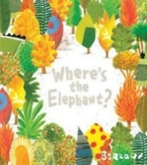 | Barroux – Where’s the Elephant?  The visual narrative works on two levels conveying the message about the destruction of our rainforests. Good for discussion at KS1/KS2. | Y
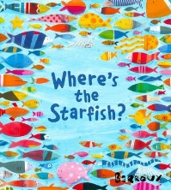 | Barroux – Where’s the Starfish?  A wordless picture book that invites discussion about pollution and the environment. The search for the starfish on every page starkly illustrates the impact of humans and their rubbish on marine life and its habitats. | Y
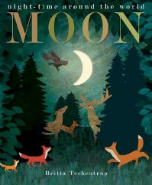 | Hegarty, Patricia – Moon  Moonlight from the waxing and waning moon illuminates the activities and industry of nocturnal animals around the world in a range of habitats. Beautiful illustrations, a series of die cuts depicting the lunar cycle and suitably descriptive text make this a great introduction to Geography at KS1. | Y
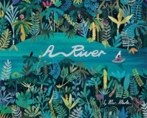 | Martin, Marc – A River  A girl takes an imaginative journey down the river she sees from her city apartment through various landscapes and down to the coast where the river flows into the sea. Good for geography at KS1/KS2. Great for an appreciation of poetry too. | Y
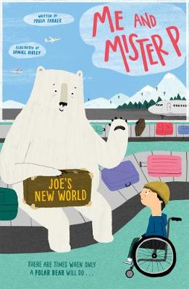 | Farrer, Maria – Me and Mr P – Joe’s New World  Joe’s parents have decided to emigrate, a situation that Joe is far from happy about. His reluctant arrival in a strange new country is further complicated by a friendly polar bear who attaches himself to the family and then helps Joe make the transition to life in a new place. | CF
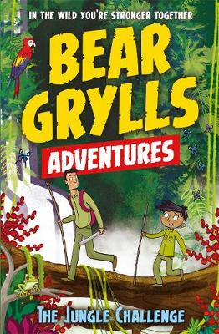 | Grylls, Bear – The Jungle Challenge  Each book in this 12-book series from Bear Grylls follows a different child on the outdoor activity camp. Once they are given the magical compass, they meet Bear in an amazing place and learn new skills and facts they can take back with them to their real life. Other titles in the series include Arctic, Desert, and River Challenges. Good for KS2. | CF
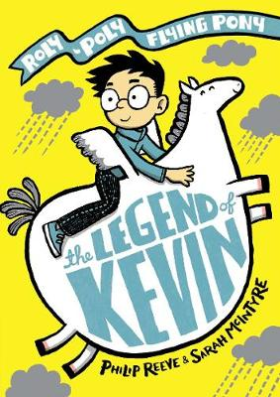 | Reeve, Phillip – Legend of Kevin  This joyous fantasy adventure revolves round Max who lives in a high rise flat and his new-found friend Kevin the winged pony. A ferocious storm brings them together, the river bank bursts, the town floods and Max, Kevin and the townspeople must find a way to deal with the consequences of this unprecedented 'natural disaster’. Also includes mermaids! | CF

Non-Fiction

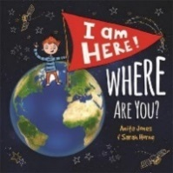 | Jones, Anita – I am Here! Where are You?  A boy explores his location starting from the room he is sitting in, zooming right through to our place in the universe. A good KS1 resource that also supports the Geography curriculum at KS2. | 307
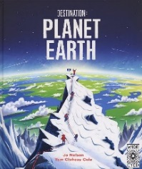 | Nelson, Jo – Destination Planet Earth  Explores all aspects of Physical Geography. Comprehensive overview for KS2 with full page illustrations and fact filled text boxes. | 551
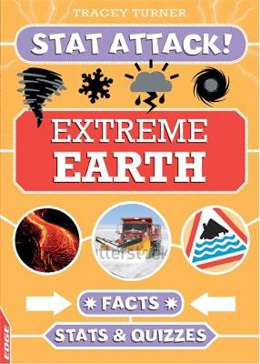 | Turner, Tracey – Extreme Earth  There are plenty of fun lists, quizzes and statistics about our planet and the world we live in in this edition in the ‘Stat Attack’ series. Provides good topic support for Upper KS2. | 551
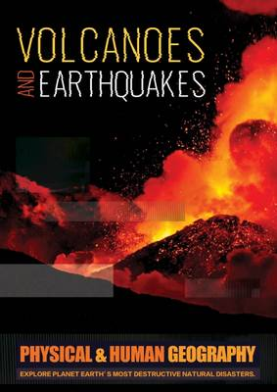 | Brundle, Joanna – Volcanoes and Earthquakes  Lots of photographs, diagrams and maps illustrate the causes, features and effects of volcanoes and earthquakes. Good case study examples too. Aimed at KS2. | 551.2
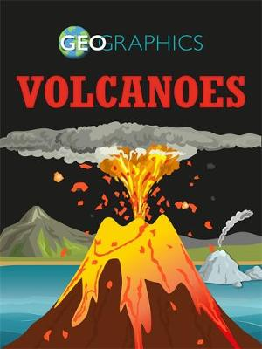 | Howell, Izzi – Volcanoes  The Geographics series uses colourful infographics and photos to illustrate universal geography topics such as rivers and coasts, earthquakes and biomes. This title looks at Volcanoes, what cause them and their impact on the landscape. Specifically includes Vesuvius, Fuji, Krakatoa, Mauna Loa and the Icelandic volcano Eyjafjallajokull. | 551.2
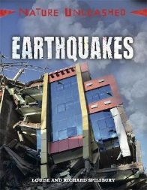 | Spilsbury, Louise & Richard – Earthquakes  A ‘worst’ top ten of Earthquake disasters around the world. An opportunity to compare and contrast the impact of these natural disasters, and our response to them. | 551.2
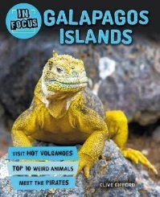 | Gifford, Clive – Galapagos Islands  A wealth of information covering many aspects of the Galapagos Islands including its geographical features and landscape, and its unique wildlife population. Covers Darwin’s connections with the Island so good for Science as well as Geography. Well presented, magazine-style format with good photos. | 551.42
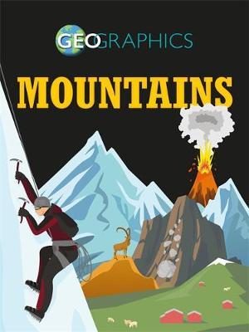 | Howell, Izzi – Geographics – Mountains  Another title in The Geographics series This title presents information about mountains, including how they are formed, the wildlife that inhabits them, and how humans interact with them. Includes focus on the Alps, the Andes, the Himalayas, the Appalachian Mountains and the Rocky Mountains. Good for Upper KS2. | 551.43
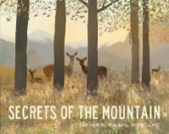 | Walden, Libby – Secrets of the Mountain  A beautifully illustrated and lyrically descriptive approach to the presentation of information in this title. The landscape, terrain and wildlife on the mountain are explored over the course of a day and a night. KS1/lower KS2 | 551.43
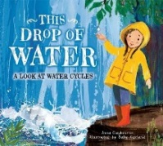 | Claybourne, Anna – This Drop of Water  From the beginnings of a thunderstorm a little girl follows the progress of the water cycle with lots of questions and answers. The narrative tone and illustrative style are engaging and absorbing. She encounters seas, skies, snow, stalagmites and sewers, amongst other things, in her quest to understand the water cycle. A great resource for Year2/3/4. | 551.46
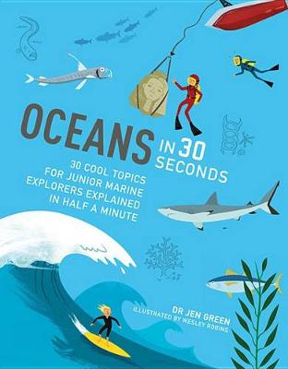 | Green, Jen – Oceans in 30 seconds  Covers a broad range of ocean related topics in a fact-packed, quick fire presentation. Practical experiments and good glossary pages in amongst the brightly illustrated information. | 551.46
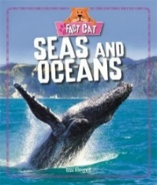 | Howell, Izzi – Seas and Oceans  Fact Cat books are a popular and reliable series for KS1 topics. This title gives a definition for ‘seas’ and ‘oceans’ looks at polar, tropical and temperate seas as well as principal features and how we use the ocean. Great photos, always accessible and engaging. | 551.46
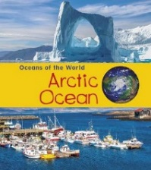 | Spilsbury, Louise & Richard – Arctic Ocean  Part of the Oceans of the World series includes, Atlantic, Pacific, Indian and Southern (Antarctic) Ocean. Each title looks at Physical geography as well as other features of the region, wildlife, islands, and ports. Good KS1 accessible resource with great photographs. | 551.46
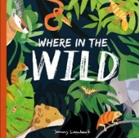 | Bishop, Poppy – Where in the Wild  A beautifully illustrated book with rhyming text. Provides a good introduction to animals and their habitats, and opportunities to discuss the importance of conservation. | 577
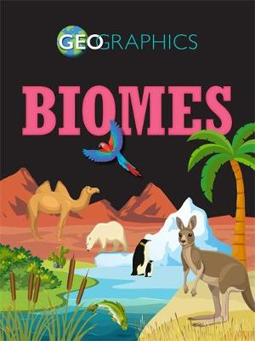 | Howell, Izzi – Biomes  The Geographics approach to biomes. Looks at forest, grasslands, deserts, ice, oceans, lakes and rivers with ‘focus’ pages on Yosemite, the Amazon, Serengeti etc. Considers climate, people, plant and wildlife and their adaption and survival in these landscapes. Good KS2 resource. | 577
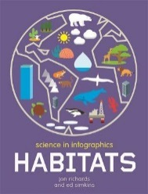 | Simkins, Ed (Illustrator) – Habitats  Eye-catching infographics format presents a stunning array of facts in a highly visual way. Covers a comprehensive range of habitats including temperate and evergreen forests, Tundra, the Poles, as well as deserts, mountains, rivers etc. | 577
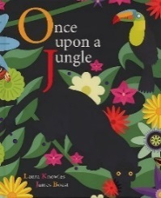 | Knowles, Laura – Once Upon a Jungle  A great introduction to the topic rainforest and particularly food chains in the rainforest. Poetic and rhythmic text with bright full-page illustrations vividly describe the cycles of life and death in the jungle. Fabulous for KS1. | 577.16
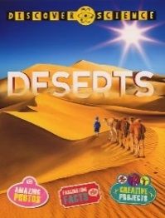 | Davies, Nicola – Deserts  Clearly presented text against a background of good, relevant photographs. Looks at different types of desert, including ‘cold’ deserts, their physical geography, and animal and plant life. Also explores the way in which they are used by man and what is gained from them in terms of resources, living and even leisure activities. | 577.54
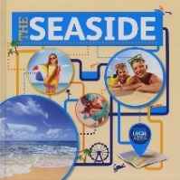 | Brundle, Joanna – Seaside  This title looks at ‘the Seaside’ from a ‘human geography’ point of view and considers historical, geographical and environmental features that impact on the seaside. Clearly presented text with photographs. Good for KS1 and 2. | 577.69
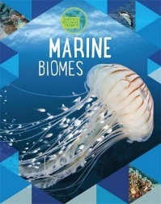 | Spilsbury, Louise & Richard – Marine Biomes  Titles in the Biomes series include Desert, Forest, Freshwater, Grassland and Tundra. This edition explores the plant and animal life that live in marine environments. A good series providing topic support for KS2. | 577.7
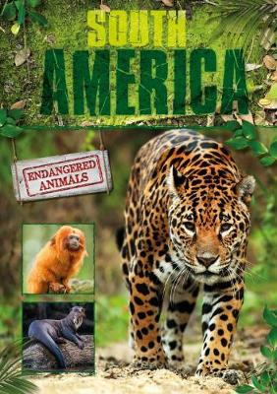 | Jones, Grace – South America  This title focuses on Endangered Animals across the continent of South America. Considers the factors that influence animals becoming endangered, as well as looking at conservation efforts in the region. | 591.68
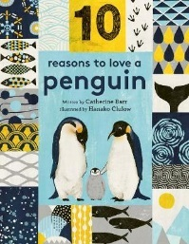 | Barr, Catherine – 10 Reasons to Love a Penguin  As well as demonstrating 10 amazing things about penguins, the text proffers 5 ways to show that you care for these remarkable creatures. Other titles in the series look at turtles, elephants and whales. | 598
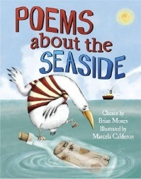 | Moses, Brian (collator) – Poems about the seaside  A selection of poems by different authors about popular seaside themes; some light, some more serious. Action rhymes and riddles too. Great support for this popular KS1 topic. | 821MOS
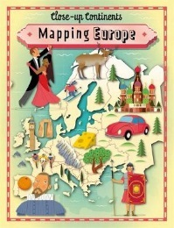 | Rockett, Paul – Mapping Europe  This title explores Europe through a collection of illustrated maps and photographs. There is a title in the series for each Continent. Good for KS2. | 914
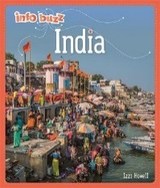 | Howell, Izzi – India  Good general introduction to India for KS1. Accessible format covers location, climate, wildlife, festivals and food, as well as place of interest. There is a quiz too. | 915.4
 | Gogerly, Liz & Hunt, Rob – Journey Through the USA  The book takes the reader on a journey through notable parts of the USA, imparting information about North America's geography, history and culture. The nine books in the series include the UK and India and provide good topic support for Upper KS2. | 917.3
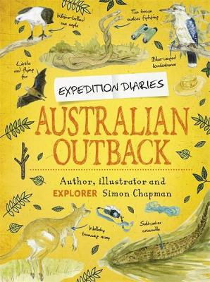 | Chapman, Simon – Australian Outback  Terrific series that uses an ‘expedition’ diary format to explore biomes around the world. A mixture of photographs and illustrations, and different font and text styles create an absorbing, engaging and informative series that is good for topic support and wider reading. Others in series include Borneo Rainforest, Amazon Basin, Himalayan Mountains, African Savannah and Indian Lowlands. | 919.4
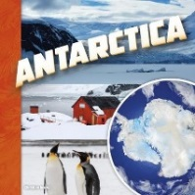 | Juarez, Christine – Antarctica  Considers a range of geographical factors, both human and physical, on the continent of Antarctica. Great photographs back up the factual text. Sound topic support for KS1/lower KS2. | 919.8
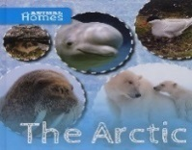 | Wood, John – Arctic  This title focuses on the Arctic as a habitat and the animals that live there. Includes Lemmings and Beluga whales as well as Polar bears, arctic terns and walruses. Considers the environmental threat to the Arctic and to endangered animals. A good introduction to the diversity of life in the Arctic for KS1. | 919.8

Y = Picture Book
CF = Children’s Fiction

If you would like to buy some of the titles on this list, go to www.petranet.co.uk and log in using your School Library Service username and password. The list will be available to see in ‘View your Bookshelf’ on the left-hand side of the home screen.

Your SLS password will give you 26% discount on most titles and books can be jacketed and serviced. If you do not have a password for Petranet, please email hq.sls@hants.gov.uk or phone 01962 826660.

This list also includes some older titles that may not be available for purchase. We may be able to provide some of them, for loan, from our shelves so please do ask.

These materials are the property of Hampshire School Library Service, please ensure that you do not reproduce or publicise these on any public access website.

