KS1 Fieldwork Fun at Colden Common!
Fieldwork is an integral part of the geography curriculum. The curriculum aims to “inspire in pupils a curiosity and fascination about the world and its people that will remain with them for the rest of their lives”, and how are children able to build up a fascination about the world around them if they are not able to get out there and see it for themselves? This brings the challenge of providing children across the primary age range age-appropriate opportunities to see the world, whether that be local or something on a larger scale. As well as this, teachers may need to consider how fieldwork opportunities could leave a lasting positive impact on the children whilst meeting and supplementing curriculum objectives.
As a relatively new teacher writing from a Key Stage 1 perspective, the knowledge focussed curriculum may, at first glance, not immediately lend itself to a huge range of exciting and engaging fieldwork opportunities. We are required to teach about the UK and a ‘contrasting non-European country, for example. Yes, it would be fantastic to visit Australia or Nairobi (popular case studies for this objective) but it clearly is not practical to do that, especially with an entire year group of enthusiastic 7 year olds! With that, it is our job as teachers to find opportunities that are just as exciting and awe inspiring, but perhaps a little closer to home. This was a challenge we faced when investigating locations for our Year 2 ‘Off to the Seaside’ topic. The focus of the topic was to investigate physical and human features of an area in the UK, whilst being able to practise and apply geographical skills such as mapping, observing and using resources like photographs to glean information. Much of the Key Stage 1 curriculum focuses on the local area, so we wanted to take the opportunity to create that ‘awe and wonder’ – the key to successful, impactful fieldwork – and go a little further afield. Rather than settle on a ‘local’ beach such as Bournemouth or Southsea, which both ran the risk of a large number of the children having already visited, we chose to visit the Isle of Wight. Even mention of the islands name sparked huge interest in the children, so children were engaged weeks before the fieldwork took place. This level of excitement and anticipation directly impacted on what the children got out of the trip. They wanted to be there, not just because they weren’t at school, but because they were visiting a new place for the first time, a place they actually wanted to explore and find out more about.
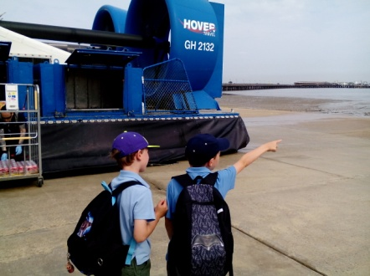
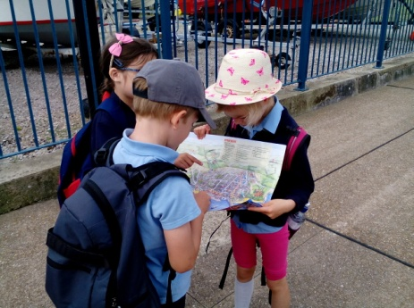
We started the day by travelling to the island by hovercraft. Without any teacher input or questioning, the geographical language was flowing before we’d left the terminal, with children already discussing the differences between the landscape they were leaving and the landscape they could see on the horizon. I had expected the children’s geographical knowledge to be more evident here than in the classroom, but, as an NQT at the time of the trip, I was shocked as to the level at which this occurred. Children that found it difficult to focus in class were leaders of groups, at the forefront in terms of demonstrating their geographical skills. In addition, it acted as a fantastic assessment opportunity – children may be able to reel off a list of map features and follow a route hypothetically in the classroom, but using a map of Ryde on location not only enabled them to apply their skills, but also emphasised to the children the need for such skills in everyday life.
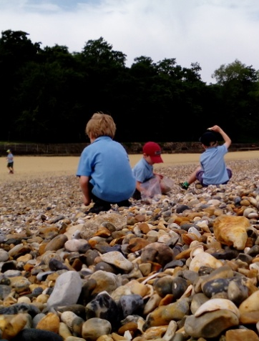
Specialising in primary geography at university, I was introduced to the playful approach to the subject, and the need to allow children time to connect with places. I have since come to believe that this is another essential part of making fieldwork successful. Amongst the organised teacher led activities, it is important to let children explore at their own pace and create their own personal relationships with place. This allows them to appreciate landscapes in a way that is meaningful to them, adding to the long term impact of the trip. For example, one child liked to dig up and collect rocks in his garden at home. He revelled in the opportunity to ‘forage’ on the beach and collect armfuls of unusual rocks and shells (most of which ended up in my rucksack, but teachers may need to make sacrifices to nurture curiosity!!) He still learnt about the features of, and similarities and differences between, his local landscape and the island landscape, but with a specific focus on something special to him – something he wouldn’t have been able to achieve without time to engage and interact with the location himself.
All the other activities on the island were led by school staff and included observational drawing, ‘landmark bingo/photo trail’ (matching photos to the environment on our walk from the hovercraft to our beach location), scavenger hunts (to encourage close examination of the features of the environment), a look at the Portsmouth skyline and what it contains (creating links with trade and tourism) and using photographs to compare how the island landscape has changed over time. We did also manage to find time to stop and get everybody an ice cream as well!
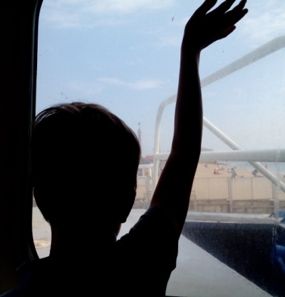
Sadly, we did have to say goodbye to the island after a long day, but it was wonderful to have seen the children’s geography come alive, and to see the children so enthusiastic and engaged. Of course, this may still have been the case had we done the fieldwork in a more familiar, local place, but I would question whether that would have created such a lasting impact.
The Local Area
As has already been mentioned, much of the Key Stage 1 geography curriculum is based around local area study. Whilst it is exciting and awe-inspiring to visit locations such as the Isle of Wight, the benefit of high quality local area study must not be underestimated. It is important for children to build up an understanding of the features of their own environment before they can expand and build upon these ideas in the context of the wider world.
In Colden Common, we are lucky to have great examples of ‘village landscapes’ within minutes from the school, including a car park, village green, play park, skate park, shops and a range of house types. A large number of the children live in the village too, meaning they are very familiar with its features. Although this could be seen as a barrier to new learning, it does also give the opportunity for children to lead their own learning. They already know what is there, so what would they like to learn? What do they want to find out? What information could they get from further investigation? This is the driving force behind our ‘Walk in the Park’ local area study.
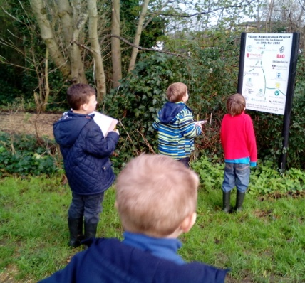
Children are given the opportunity, with some guidance, to decide how they want to organise their ‘walk in the park’ along with the information they are going to collect. This then provides the foundations for our learning across all subjects following the walk. For example, something most children were keen to find out was how the park is used and by who, and what the most popular part of the park was.
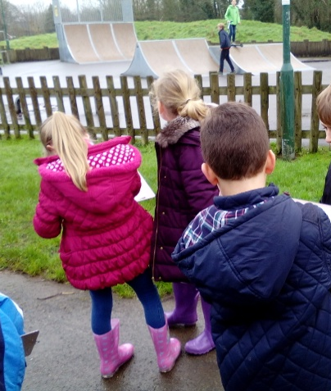
With this in mind, we came up with our own data collection sheets and went to the park to investigate. Giving the walk a focus allowed the children to organise their ideas and examine areas of the park more closely than they normally would have done. Rather than heading straight for the play equipment as they might do at the weekend, they were taking notice of who was there and what they were doing. In a sense, they were beginning to look at the world – their ‘local world’ - from a different perspective, allowing them to begin to make links between geographical knowledge learnt in the classroom and real-life situations. The children were able to voice their own opinions about the area too, including their likes and dislikes, which made the trip more relevant for them and would go on to inform their learning back in the classroom.
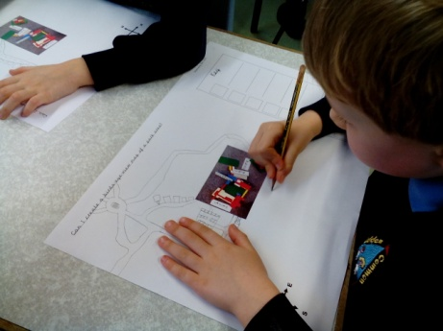
The walk to the park only took just over an hour, and although it was on a much smaller scale than our Isle of Wight trip, the wealth of enquiry questions it raised was able to provide the basis for our learning in the weeks that followed. For example, children were able to design their own park whilst thinking about which features of the local environment worked well and were popular, and which were less so. Creative opportunities for mapping could be included too, with children building a park environment using construction kits and then using their mapping skills, such as keys and symbols, to extend an aerial photo of their model to expand to a local area landscape.
The topic itself is perhaps focussed around human geography, given the village location, however, this provides opportunities to expand the geographical learning and make links with other subjects to find out information. For example, this year we are going to use the data we collect on the walk (who goes to the park and why) to create and interpret graphs in Computing. This means the children will be able to use new and learnt Computing and data handling skills to find answers to the geographical questions they wanted to investigate at the start of the topic. We will then move to sorting, organising and categorising local area features in a branching database format.
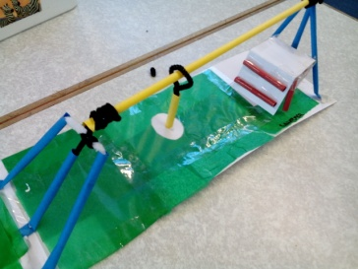
Additionally, our DT work will involve designing and creating our own piece of playground equipment. Children will have investigated the mechanisms of the play equipment during our walk, and will use this to decide on an appropriate design. Children will also need to think about the location of their equipment within the local environment. This will bring together their knowledge of local physical and human features, whilst working on their reasoning skills. Is the existing play park in the best location? Should it be near a car park? Should it be near a shop? Why?
Whilst there are also disadvantages to fieldwork, such as the organisational logistics (booking 50 tickets for a hover craft!), the awe and wonder visits can create is extremely valuable in helping children to build up a personal understanding of the world around them. Their lasting impact on children can inspire them to want to continue exploring the world and can encourage children to access the curriculum in an exciting, engaging way.
Jason Cannons

