GEOGRAPHY BOOK CORNER

The start of the new academic year brings a variety of titles that are available to support the Geography curriculum at KS1 & 2. Don’t forget to consider fiction titles to go alongside topic books as they can add a new and often interesting dimension to learning. This small selection highlights just some of the books that are available to borrow from the Hampshire School Library Service for all subscribing schools.

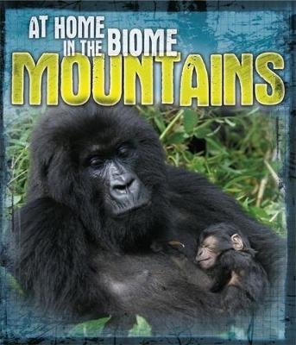
At Home in the Biome – Mountains
by Louise and Richard Spilsbury – 577
This title looks at mountain biomes and how the animals and plants that live within them survive and have adapted to these often hostile and challenging places. Full of facts and colour photographs, the ‘At Home in the Biome’ series also includes: Coral Reef, Rivers and Lakes and Wetlands. A good topic support for KS2

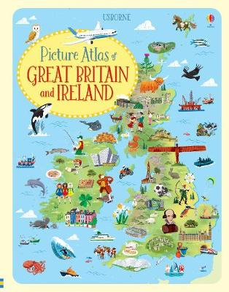
Picture Atlas of Great Britain and Ireland
By Jonathan Melmouth – 912
This picture atlas takes you on a tour of the British Isles. With ten detailed picture maps, children will find out about the wide range of things to see and do as well as locating landmarks, famous people and animals and plants. Full of facts and information for KS2.

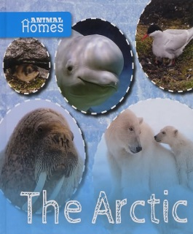
The Arctic
by John Wood – 919.8
This exciting new series introduces young readers to the diversity of life on our planet. It explores the variety of habitats in our world and explains how animals have adapted to be able to make their homes in each and every one of them. This particular title looks at the Arctic habitat and looks at the animals that live there. Other titles in the series include: Deserts, Forests, Mountains, Oceans and Rainforests. Good topic support for KS1.

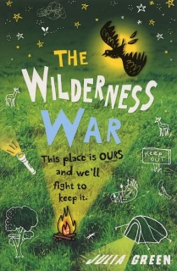
The Wilderness War by Julia Green
A group of children band together to protect an overgrown patch of land they play on from being bulldozed by a property developer, but one day their Wilderness is sold and set for development and their dens torn down to make way for houses. For Noah and his friends this means war and they'll do anything to stop the Wilderness being destroyed. A good fiction title with an environmental message for KS2.

