GEOGRAPHY BOOK CORNER

Whatever topic you are covering in Geography this term, there are plenty of books available to support the curriculum. Don’t forget to consider fiction titles to go alongside topic books as they can add a new and often interesting dimension to learning. This small selection highlights just some of the books that are available to borrow from the Hampshire School Library Service for all subscribing schools.

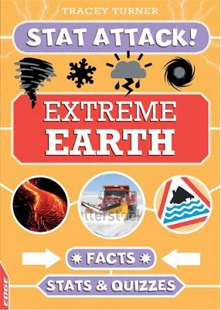
Extreme Earth by Tracey Turner - 551
A book filled with facts and statistics about our planet. Part of a really engaging series, this title concentrates on physical geography and contains facts about habitats, and natural disasters and also includes a quiz at the end of each section. A good bowser that is sure to be popular with pupils, but the title also works well for topic support at KS2.

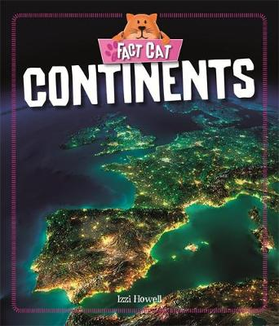
Continents by Izzi Howell - 910
This title explores the seven continents and the landscapes that make each continent special. With fun facts about the size and population of the continents and information about the people and animals that live there, the book has plenty of appeal for KS1 & Lower KS2. Other titles in the Fact Cat geography series include The Equator, The Poles and Seas and Oceans.

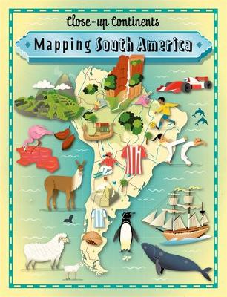
Mapping South America by Paul Rockett - 917
This unique series gets close up to some amazing areas of our world, and allows readers the opportunity to explore key countries, topographical features and cities in a way that is both engaging and entertaining. Other books in the series include Africa, Asia, Australasia, Europe and North America. A good addition to geography collections for Upper KS2.

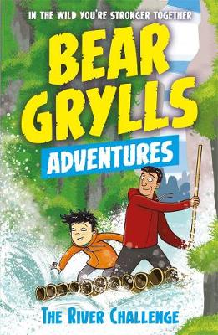
The River Challenge by Bear Grylls
Each book in this fiction series by Bear Grylls follows a different child on an outdoor activity camp. Once they are given the magical compass, they meet Bear in an amazing location and learn new skills and facts they can take with them back to their real life. This title follows Jack as he navigates the rapids of a Chinese river gorge. Other books in the 12-book series include The Desert Challenge, The Earthquake Challenge and The Jungle Challenge and are ideal to accompany geography topics for KS2.

