Karen Falcon

April 2021

Final version

© Hampshire County Council

Developing Primary Geography

An overview for schools

HIAS MOODLE+ RESOURCE

Overview

This document contains…
An overview of the discipline of geography and how primary schools can be supported by HIAS.

Points to consider when using this resource
The offers may vary slightly each year.

Developing geography in primary schools

Geography is the best subject (I am biased) as it brings together the physical and human world through studying places both local and global. It is effective when new learning is connected to the local area that children are familiar and it is most effective when the skills are used to teach new learning. When we are planning geography, we need to ask ourselves “are we developing geographers or are we teaching geography theory?” It is common for schools to teach a lot of content with some skills scattered throughout the year groups, so we want to change the lens that geography is taught through. The new lens is one that focuses on teaching skills that allow children to work as geographers to learn new knowledge and gain understanding. Being able to read sources such as maps, photos, graphs, videos, plan perspectives, aerial photos, and OS maps geographer using their geography eyes is key to becoming a geographer. Using fieldwork as a teaching method to help children see geographical concepts in a local context is paramount to helping children become geographers. Allowing children to talk, listen, question and discuss what they are observing, finding and understanding is a teaching method which needs to be promoted and adopted for teaching and embedding the high specific vocabulary that helps children explain this special subject

What is geography?
Geography is a very broad subject and is one of the only, possible the only, subject in which you can study for a BA or BSc. Regent College London summarise the two degrees in the following sentences

Bachelor of Arts allows for more qualitative, creative thinking whilst developing theoretical and critical thinking. A Bachelor of Science features a more technical and mathematical approach which promotes in depth and detailed thinking as well as improving analytical and statistical skills.

The subject of geography encompasses the whole spectrum of thinking which is why it often has an identity crisis and struggles with progression in primary school. The evidence for this is that human topics are usually totally different to the physical topics which are usually totally different from the place topics. They all have a specific identity which is driven by the content and our challenge is to drive with geographical concepts and skills and have the content giving context for skill, concept and vocabulary progression.

It would be a good time to watch a short video which explain what geography is and you can follow the link below or type ‘Geography: what is it for. https://www.youtube.com/watch?v=sgGb8BM2TBk The video is made by Teaching and Learning in South Australia and if you watch until 2 minutes 14 seconds you will get a dual coded explanation of geography which finishes with a double helix with ‘Geographical inquiry and skills’ on one strand and ‘Geographical knowledge and understanding’ on the other.

A summary of primary geography concepts, lessons, thinking, and answers is shown in table 1 and this is what we are aiming for in our curriculum and lesson planning and delivery.

Geography concepts | Lessons should allow children to | Thinking | Quality of answers
Human and physical  Similarities and differences  Local, UK, world places  Connecting children to places  Recognising and explaining patterns  Understanding processes  Developing map skills  Carrying out fieldwork | Observe  Talk  Listen  Question  Do | Identify  Describe  Explain  Compare  Evaluate | Accurate  Concise  Geographical vocabulary  Evidence informed opinions

Table 1: A summary of primary geography

Areas where geography curriculum may need attention

During my five years in this special role I have had the joy of working on many school geography curriculums both on a one to one basis during an school visit or on a group session such as a termly network meeting or a course. Over time I have identified patterns in geography curriculum design and planning, and these are useful reflection points for any school to consider.

1. Curriculum coverage
Is the curriculum covered appropriately? Are some sections or topics covered in great detail and are others not covered at all? For example is it common in KS2 for ‘the distribution of natural resources including energy, food, minerals and water’ to be missing from teaching. It is also common for ‘climate zones, biomes and vegetation belt’ to focus on the rainforest, particularly the Amazon. It is also common for the balance of skills, knowledge and understanding to be unequal with knowledge being prioritised followed by understanding and then skills.

In KS1 the curriculum states, ‘understand geographical similarities and differences through studying the human and physical geography of a small area of the United Kingdom, and of a small area in a contrasting non-European country.’ In KS2 it states, ‘understand geographical similarities and differences through the study of human and physical geography of a region of the United Kingdom, a region in a European country, and a region within North or South America.’ The words in bold are significant as planning and teaching must focus on children being able to make comparisons between the human and physical geography of small areas or regions in the UK and the relevant country. Very often I see place studies that compare the local area to a country, that do not compare at all, or that compare the 5 F’s: flags, food, festivals, fashion, and famous people.

2. Places
Does your curriculum take children to a range of places and places that the teachers and children can connect to and therefore bring to life? Children get the opportunity to learn about three places in detail during their primary education and it is important that these places are picked with geography eyes on rather than being led by history both as a subject and a period of time. Tuscany, Rome, India, France, Mexico, Australia, and the Amazon are all places but they are hard to justify as a geographic choice for a place study unless we narrow down the country to a small area or region. There are also times when we need to leave a place with history, e.g. Rome. Imagine planning the other way round whereby geography picks Whakapapa in New Zealand for our contrasting non-European place and asked history to follow on…

We want to pick places that are relevant to the teachers and children so that they can be brought to life by them. We want to pick places that are geographical and where similarities and differences can be drawn out when teaching. We also need to pick places that are inhabited by people so that we can look at human and physical aspects of the place. There are no right places but there are many geographically weak places.

3. Teaching and progression
Does the teaching allow geographical inquiry and skills to be developed and vocabulary, skills, and interconnections to progress? Do geography lessons look like an IT lesson or an English lesson? We want to refer to table 1 when planning, teaching and reviewing geography lessons to see if we are allowing geography lessons to have their own identity. We want to develop map skills, fieldwork skills, and knowledge that is consistent no matter what the content so that children progress as geographers and see the connections between topics.

5. Fieldwork
Does fieldwork take place? Does fieldwork follow a geographical framework or is it a trip? Is the school site and local area used repeatedly for fieldwork? The main barrier to fieldwork is the teacher so we need to support and encourage them to leave their classroom and explore the school site with their children. The Primary Geography Moodle+ has three resources which show the fieldwork process and methods as well as suggesting over 30 fieldwork questions that can be answered on the school site. Fieldwork during COVID can still take place with children exploring their classroom and certain areas around school. They can also carry out interviews on Zoom with the site manager or Headteacher when finding out about economic activity or energy waste.

Virtual fieldwork is a great activity to support learning about another place. Google earth, Google images, YouTube, www.earthcam.com and www.skylinewebcams.com are amazing sources of visual information which have a huge impact on children and their understanding of places that they cannot get to. Children in KS1 and KS2 can play ‘I spy from the sky’, with or without the teacher, using a number of these sources to explore their local area and their comparison area to identify human and physical features. Table 2 shows a simple table that can be added to for identifying and comparing areas.

Feature | Kota Kinabalu, Malaysia | Warsash
Physical
Sea
Hill
Coast
Beach
Forest
Human
Village
Town
City
Shops
House
Table 2: I spy from the sky table

How can HIAS support the geography in your school?

1. Geography Networks
Each term we run up to seven networks around the county. They are currently online, but we will get them face to face when it is safe to do so. The networks give subject leads a greater understanding of geography and demonstrate how geography should be planned and taught. The agendas for this year are shown below and searching for ‘primary geography network’ will bring up booking information on the LMS.
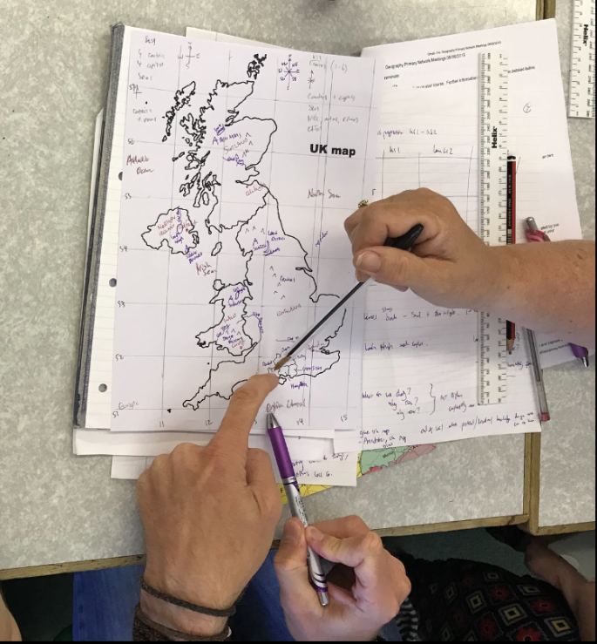
This feedback is from teachers who attended the networks

“​​Thank you! I love these sessions and always like sharing your ideas with staff.”
​“Thank you Karen. It has been really useful and informative again. Loved the geography through books and what you can get from them.”
​​“Thank you. some great ideas to use again as well as reassurances.”
​“Thank you Karen. I'm new to the role & this has given me lots of food for thought. I'll be looking at school planning in more detail now! All brill!! Thank you!”

2. Bespoke in school geography support
Schools visits online or in person are an effective way of evaluating and relaunching your geography provision. We share the resources developed for the curriculum framework so that long and medium term plans can be used as a planning tool to save the geography lead and class teachers time in planning which means they can spend more time discovering geography and finding resources to prepare for the lesson. This collaborative time is productive and informative for subject leads and teachers who receive this training.

This is a quote from a Headteacher whose staff received geography support this year

“Thank you so much for inspiring and uplifting the team! Very excited to see the plans in action and would love to book you in for another visit! The team really appreciated your time, energy and enthusiasm - with one of the Y6 team saying it was the best CPD ever! Thank you for igniting a passion for Geography around the school and for giving us the tools to succeed! We would really welcome another visit to make sure that our Geography journey unfolds in the way that we hope it to.“

3. Geography Curriculum Framework
The Geography curriculum framework has been developed to provide schools with robust foundations for a curriculum that can be built to meet the needs of their pupils using the strengths of the teachers. The framework is based on the following three principles:
- Develop geography skills in conjunction with learning geography knowledge and understanding to make connections.
- Return to concepts, skills, vocabulary, and content throughout the curriculum in order to deepen learning and support progress.
- Give geography a pedagogical identity that children recognise.

It consists of a long-term plan, tracking of the KS1 and KS2 national curriculum, 18 medium term plans, guidance and ideas for Year R, three PowerPoints to support the teaching of the first one or two lessons in each topic, age related expectations, and skills and inquiry progression.

The Geography curriculum framework can be ordered online https://www.hants.gov.uk/educationandlearning/hias/curriculum-support/publications

4. Geography courses
In the Summer term we are run a course called ‘Planning for progression in primary geography’. During the day teachers evaluate the current geography planning for their school and build a long-term plan and frameworks for medium term plans to develop the geography provision.

In the Autumn term we run a course called ‘Leading primary geography confidently and competently’ (date TBC). During the day we explore the subject of geography in terms of the planning and teaching to improve confidence. We also look at how geography can be led to ensure that there is progression within the curriculum.

Both courses are practical and teachers get to work on the planning in place in their school and I ask for laptops and planning to be brought along whether online or in person.

5. Twitter
HIAS Geography is on twitter and we share ideas, resources and CPD opportunities each week weekly. Follow us @HIAS Geography.

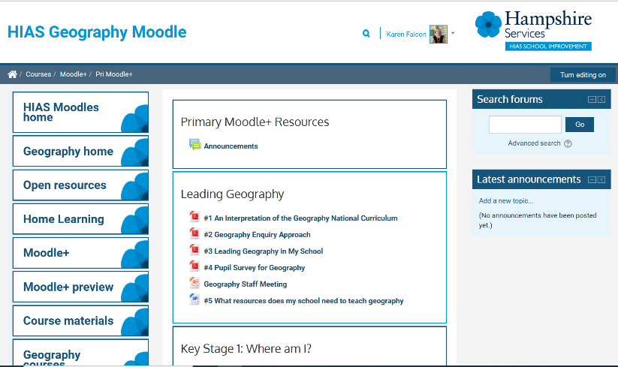
6. Hampshire Geography Moodle+
The Moodle+ area has many resources to support subject leads and teachers with their planning and teaching of geography. There are activities with resources, Medium Term Plans, guides to support subject leads with their role and resources, suggestions for teaching geographical concepts such as similarities and differences, human and physical, evaluating, and support for carrying out fieldwork. It is very accessible and clearly laid out so please direct your geography leads to this area.

7. Geography Primary News
The Primary News is published in the Autumn and Spring term and is always full of useful ideas to support teachers planning and teaching geography. We ask teachers from around county to share their experiences, planning and resources to demonstrate the story they are telling about the geography work they have been doing.

Karen Falcon – County Geography Adviser

Email: Karen.Falcon@hants.gov.uk

For further details on the full range of services available please contact us using the following details:

Tel: 01962 874820 or email: hias.enquiries@hants.gov.uk

Upcoming Courses

Keep up-to-date with our learning opportunities for each subject through our Upcoming Course pages linked below. To browse the full catalogue of learning offers, visit our new Learning Zone. Full details of how to access the site to make a booking are provided here.

- English
- Maths
- Science
- Geography
- RE
- History
- Leadership
- Computing
- Art
- D&T
- Assessment
- Support Staff
- SEN

Terms and conditions

Terms of licence
Moodle+ subscribers are licenced to access and use this resource and have agreed to pay the annual subscription fee. This authority starts when the fee is paid and ends when the subscription period expired unless it is renewed. This file is for personal or classroom use only. By using it, you agree that you will not copy or reproduce this file except for your own personal, non-commercial use. HIAS have the right to modify the terms of this agreement at any time; the modification will be effective immediately and shall replace all prior agreements.

You are welcome to:
- download this resource
- save this resource on your computer
- print as many copies as you would like to use in your school
- amend this electronic resource so long as you acknowledge its source and do not share as your own work.

You may not:
- claim this resource as your own
- sell or in any way profit from this resource
- store or distribute this resource on any other website or another location where others are able to electronically retrieve it
- email this resource to anyone outside your school or transmit it in any other fashion.

