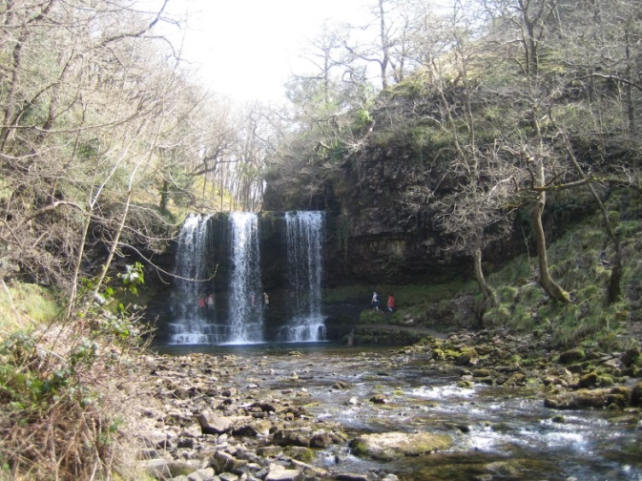
Mountains, water cycle and rivers
KS2 physical geography
▪ describe and understand key aspects of:
▪ physical geography, including: rivers, mountains and the water cycle

Skills

- Use a range of maps, atlases, images, globes and digital mapping
- Locate countries and describe features studied in the KS2 NC
- Use compass directions: N, NE, E, SE, S, SW, W, NW to follow and give directions to build knowledge of the UK and the wider world
- Accurately use six figure grid references on an map OS map
- Draw maps, sketches and plans with accurate symbols, keys and scale
- Ask geographical questions about places and environments to carry out investigations and can explain opinions from a range of view points

Country suggestions
South America: Amazon - Colombia, Peru, Brazil
North America: Mississippi, Colorado - USA
Europe: Thames - UK; Rhine - France, Austria, Liechtenstein, Netherlands, Germany, Switzerland; Danube - Austria, Romania, Bulgaria, Slovakia, Hungary, Ukraine, Croatia, Germany, Serbia, Moldova

Book suggestions
551.48 Rivers Jen Green
551.48 Rivers Barbara Taylor
551.48 Rivers Ruth Thomson
551.48 Rapid river rescue Jogn Townsend

Y River story Meredith Hooper
Y Otter Chaos (Y 3-4) M Broad
Y Journey to the river sea (Y5-6) E. Ibbotson
Y The river singers (Y4-6) T.Moorshouse

Key words to support planning
Atmosphere, condensation, evaporation, infiltration, impermeable, interception, precipitation, saturation, surface run off, transpiration, water cycle.
Bed, bank, channel, confluence, current, downstream, deposition, depth, erosion, flood, flood plain, landform, hill, meander, mouth, process, drainage basin, source, transportation, tributary, valley, waterfall, watershed, width.

Fieldwork

- Link local observations to wider world to identify patterns
- Use camera and locate photos on a map
- Draw sketch map showing human and physical features
- Devise and answer questions using geographical vocabulary
- Measure and record primary data using a range of appropriate images
- Justify and evaluate data collection methods
- Independently present data and findings using maps, graphs and digital technologies to show clear enquiry route
- Conclude fieldwork investigations with explanations and evidence

Activity | Learning
Small world or playground river | Chn make small world rivers or playground river to identify and demonstrate features and processes,
Visit to a real river | Chn visit local river to carry out river studies (contact local secondary school to borrow equipment if needed)
Flood hazards | Chn explore school grounds and local area to investigate flood hazards and the effect on people and services.

Medium term planning ideas

1 | Where are the mountains?  Chn explore what a mountain is and what makes it a mountain rather than a hill. Chn look at maps and locate mountains around the world especially in Europe, North America, South America and also Asia.
2 | How did they get there?  Chn predict and investigate how mountains were formed. Taught as a mystery and the answer is revealed slowly to support knowledge and understanding
3 | How do people use mountains?  Chn look at a specific mountain or mountain range and look at how people use them for living, farming, tourism and the links to climate and vegetation
4 | How do mountains store and move water?  Pictures of water on mountains in snow, ice, glaciers, rivers and lake. Explore questions: where from, seasonal changes, problems, origin, destination. Teach the water cycle and get chn using vocabulary accurately. What happens if.. no precipitation/evapration? Does it always happen on a mountain?
5 | What do we find along and in a river?  Use images and videos before making a small world or playground river to create a river journey.
6 | What changes the shape of a river?  Discuss processes and think of examples out of a river. Erosion of material by a digger, transportation by the digger, deposition to a pile. Chn carry out fieldwork to look for examples of processes around school. Think about job of processes in a river and how they change the shape of a river.
7 | A giant water slide of fun or use?  Look at how humans use the river and evaluate whether we use them more for fun or for work.
8 | What a sight!  Look at formation of landform (waterfall or meander), how processes change them & human use.
9 | What caused the flood?  What makes a river flood? Human and physical causes. Link back to water cycle and a local flood.
10 | How were people affected?  Focus on a local flood and impacts to people, the environment and the economy. Could compare floods
11 | How can we manage the impacts of flooding?  Look at management techniques used before or after the local floodand evaluate the impact

