Geography Book Shelf
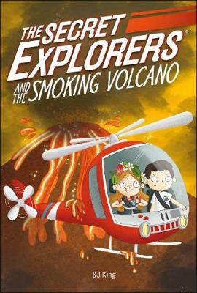
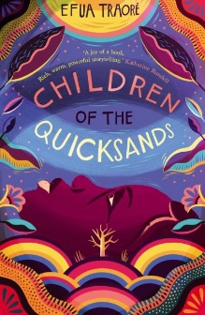
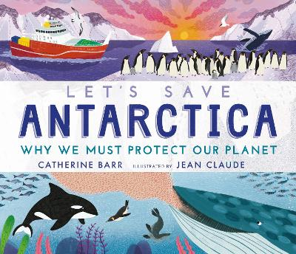

Here is a selection of new titles to support geography for KS1 and 2.

Children of the Quicksands by Efua Traore is set in Nigeria. Simi lives in Lagos and is sent to her Grandmother’s village for the summer while her Mum is away. There she finds a completely different way of life with African gods, a magical lake and a call on her life. As well as being a great story for upper KS2 this book also highlights the differences between places within Nigeria – comparing a busy, modern city with life in a rural village.

Let’s save Antarctica by Catherine Barr is a beautiful information book that is simply presented and could be used by both KS1 and 2. It gives reasons why Antarctica is so special, from Penguins and Whales to Ice Sheets, highlighting why it is so important to make sure we protect our planet. Dewey 919.8

The Secret Explorers and the Smoking Volcano by S J King is part of a series of books bringing together secret explorers from all over the world for adventures and missions. A read for years 2/3 that also gives some facts about volcanoes along the way. Other titles in this series include exploration to rainforests, the Arctic, oceans and the Jurassic coast.

Fair Trade First by Sarah Ridley is an information book that follows the fair trade story of various household foods and items. With explanations of how fair trade works, where items are farmed and some recipes along the way, this is an attractive but informative read. Dewey 382

Hampshire School Library Service provides a wealth of Fiction and Non-fiction texts to support geography across the curriculum. Books are available to borrow from the Hampshire School Library Service for all subscribing schools. We are happy to advise on individual requests to support a topic or subject area, and provide resources via the courier or a request and collect service, as well as our regular exchanges. You are always welcome to visit one of our bases to explore the range of resources available for yourselves. Contact us through your own School Librarian or request details of your local base via hq.sls@hants.gov.uk. We look forward to hearing from you.

