GEOGRAPHY MEETING SPRING 2018
PLACE

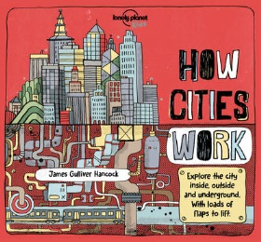 | Hancock, James Gulliver – How Cities Work  An interactive book which shows the features of a city and what goes on in, around and under the places you might see. A different way of looking at and learning about the cities we live in for KS2. | 307
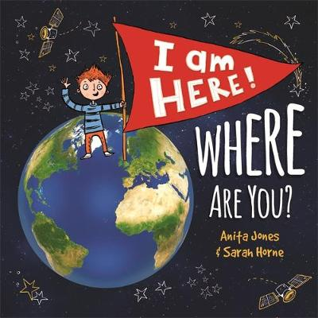 | Jones, Anita – I am Here! Where are You?  A boy explores his location starting from the room he is sitting in zooming right through to our place in the universe. A good KS1 resource that also supports the Geography curriculum at KS2. | 307
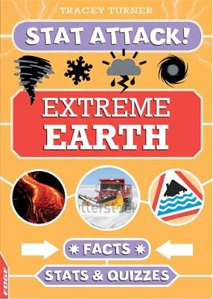 | Turner, Tracey – Extreme Earth  There are plenty of fun lists, quizzes and statistics about our planet and the world we live in in this edition in the ‘Stat Attack’ series. Provides good topic support for Upper KS2. | 551
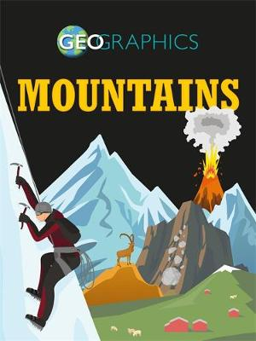 | Howell, Izzi – Geographics – Mountains  The Geographics series uses colourful infographics and photos to illustrate universal geography topics such as volcanoes, rivers and coasts, earthquakes and biomes. This title presents information about mountains, including how they are formed, the wildlife that inhabits them, and how humans interact with them. Good for Upper KS2. | 551.43
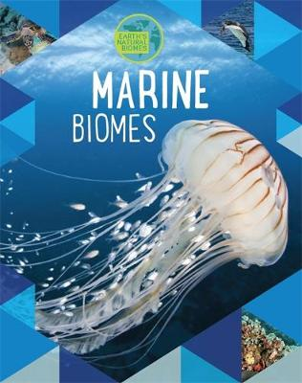 | Spilsbury, Louise & Richard – Marine Biomes  Titles in the Biomes series include Desert, Forest, Freshwater, Grassland and Tundra. This edition explores the plant and animal life that live in marine environments. A good series providing topic support for KS2. | 551.46
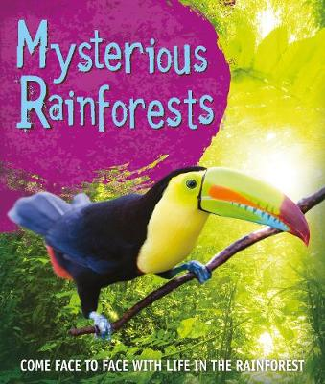 | Mysterious Rainforests  A visual guide to rainforests around the globe. Journey from the forest floor right up into the emergent layers of the rainforests - home to the most diverse and exciting range of wildlife on the planet. Ideal for Upper KS1/Lower KS2. | 577.34
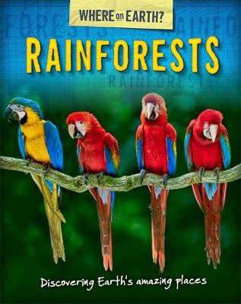 | Brooks, Susie – Rainforests  This title presents the environment of the rain forest in the style of question-and-answer format. Full of interesting facts and useful information providing good topic support at KS2. | 577.34
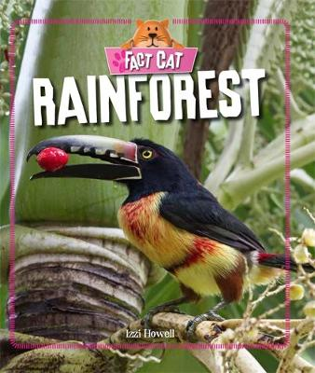  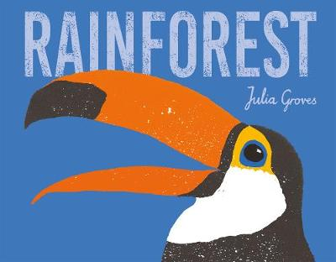 | Groves, Julia – Rainforest  Factual information alongside beautiful illustrations providing a good introduction to the rainforest environment looking at conservation and adaptation. Good to run alongside the topic and can be used in different ways at KS1 and 2.  Howell, Izzi – Rainforest  An accessible, clearly laid out overview of the topic providing good support for Upper KS1 and KS2. | 577.34  577.34

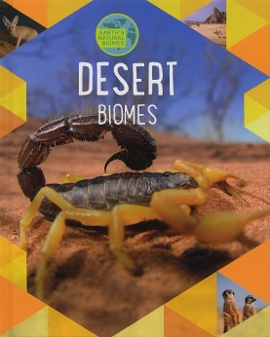 | Spilsbury, Louise & Richard – Marine Biomes  Titles in the Biomes series include Forest, Freshwater, Grassland, Marine and Tundra. This edition shows where deserts are found, explores the amazing animals and plants of the desert and how they have adapted to their environment. Good KS2 topic support. | 577.54
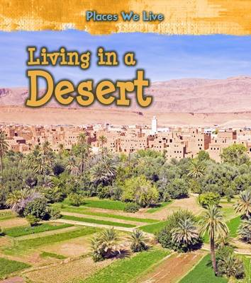 | Labreque, Ellen – Living in a Desert  Discover how people adapt to living in deserts. Looking at everything from why deserts are found in certain places, to how people fulfil their basic needs, such as getting food and water, in such an extreme climate. Good for KS1 and 2. | 577.54
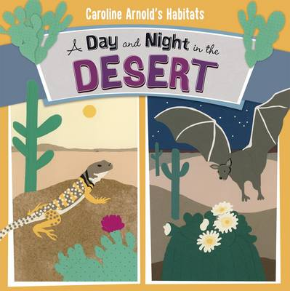 | Arnold, Caroline – A Day and Night in the Sonoran Desert  This book follows the lives of desert animals throughout one day in the Sonoran Desert that spans California and Mexico. A lovely accompaniment to the topic for KS1 & 2. | 577.54
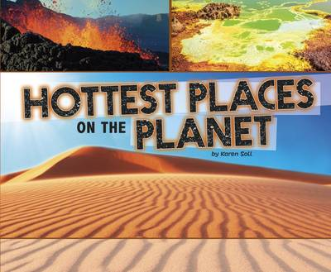 | Soll, Karen – Hottest Places on the Planet  This title explores some of the hottest places around the world, why they are so hot, and who lives there. Other titles in the series include Coldest, Highest and Lowest Places on the Planet. Facts are accompanied by large format colour photographs. Topic support for KS1 & Lower KS2. | 910

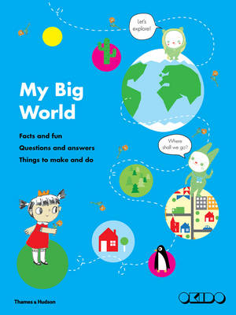 | Dauvois, Sophie – My Big World  A first book of geographical facts and information about our planet that is ideal KS1. Take a journey from home to outer space and find out about our big world, including its oceans and rivers, mountains and forests, plants, animals and weather. | 910

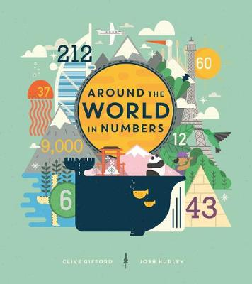 | Gifford, Clive – Around the World in Numbers  A book bursting with numbers and extraordinary statistics and facts that tell a story about the people, creatures and cultures of the world's continents. The title covers a wide range of topics from famous landmarks and bustling cities to hidden treasures, fascinating discoveries and amazing feats. Good for KS2. | 910
 | Thurlby, Paul – L is for London  Discover London's best-loved landmarks and iconic ways of life through the eyes of illustrator Paul Thurlby. From Abbey Road to the London Zoo, this book brings the sights and sounds of the capital to life for KS1 & 2. | 914.21
 | Ganeri, Anita – Introducing Asia  A good topic support for KS1/lower KS2 covering the location of Asia, its climate, geography, animals and plants, countries, people and languages, natural resources, cities, and famous places. Other books in the series introduce Africa, Antarctica, Australia, Europe, North and South America. | 915
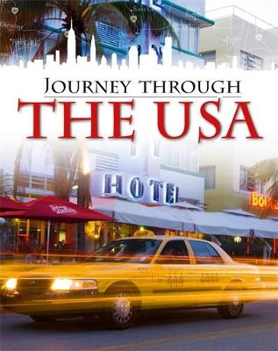 | Gogerly, Liz & Hunt, Rob – Journey Through the USA  The book takes the reader on a journey through notable parts of the USA, imparting information about North America's geography, history and culture. The nine books in the series include the UK and India and provide good topic support for Upper KS2. | 917.3
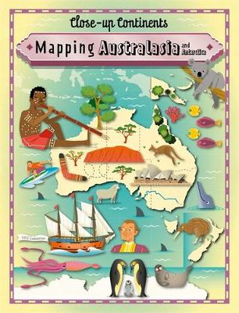 | Rockett,Paul – Mapping Australasia and Antarctica  This series covers the seven continents and this title looks at Australasia and Antarctica through a collection of illustrated maps and photographs. Good for KS2. | 919

FICTION

 | Bailey, Ella – One Day on our Blue Planet…in the Antarctic  A first look at Antarctic wildlife following a penguin chick as she leaves the nesting ground and sets out across the vast Antarctic ocean. Good for KS1. | Y
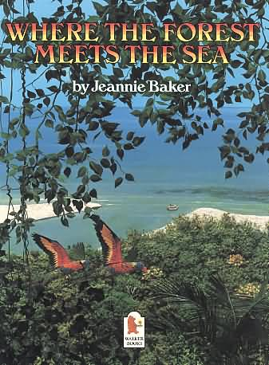  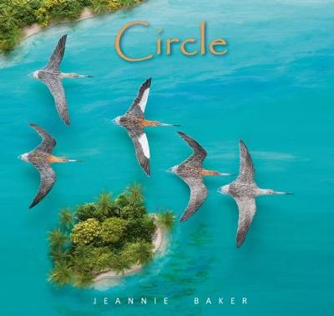 | Baker, Jeannie – Where the Forest Meets the Sea  This fascinating and innovative picture book chronicles the reflections of a young boy, exploring a prehistoric rain forest in North Queensland, Australia. Good KS2 topic support.  Baker, Jeannie - Circle  A boy explores his location starting from the room he is sitting in zooming right through to our place in the universe. A good resource that also supports the Geography curriculum at KS2. | P  P
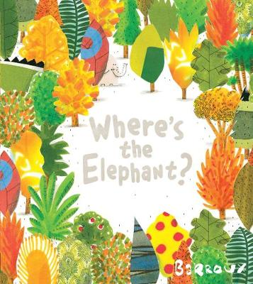 | Barroux – Where’s the Elephant  The visual narrative works on two levels conveying the message about the destruction of our rainforests. Good for discussion at KS1/2. | Y
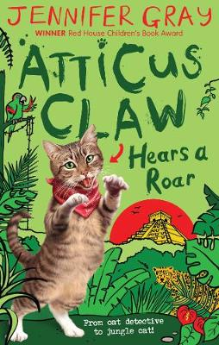  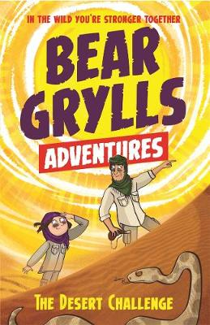  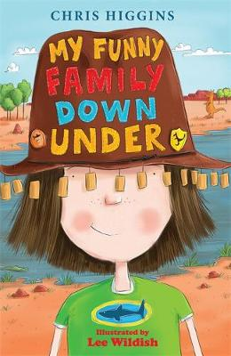  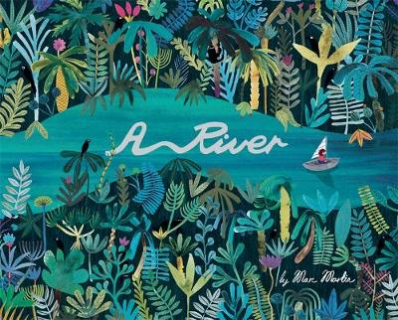 | Eastham, Ruth – The Jaguar Trials  Thirteen-year-old Ben finds himself in South America, in the heart of the Amazon jungle, and stumbling into an ancient mystery. Along with two local children, he is determined to solve the trials of El Dorado, lift the curse and find his missing Father. Good topic accompaniment for Upper KS2.  Gray, Jennifer – Atticus Claw Hears a Roar  Atticus Claw travels to South America in his seventh mystery for KS2. After finding a mysterious case in the attic and a book leading to the treasure of the lost jaguar gods Atticus is plunged into a jungle adventure.  Grylls, Bear – The Desert Challenge  Each book in this 12-book series from Bear Grylls follows a different child on the outdoor activity camp. Once they are given the magical compass, they meet Bear in an amazing place and learn new skills and facts they can take back with them to their real life. Other titles in the series include Jungle, Sea and River Challenges. Good for KS2.  Higgins, Chris – My Funny Family Down Under  A family adventure down under for KS2. Mattie and her family travel to visit relatives in Australia and learn about how different life on the other side of the world can be.  Martin, Marc – A River  A girl takes an imaginative journey down the river she sees from her city apartment through various landscapes and down to the coast where the river flows into the sea. Good for geography at KS1/2. | CF  CF  CF  CF  Y

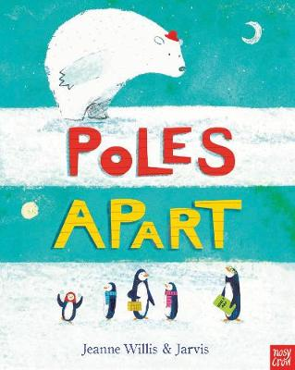 | Willis, Jeanne – Poles Apart  A Polar bear joins a family of lost penguins on this KS1pole-to-pole adventure around the world to return them to their home in the South Pole. | Y
Y = Picture Book/ P = Picture Book for Older Readers
M = First Steps/N = Next Steps
CF = Children’s Fiction
T = Younger Teen Reads/T+ = Older Teen Reads

This list has been created using some older titles that may not be available for purchase. We may be able to provide some of them, for loan, from our shelves so please do ask. Titles that are available to buy can be found by searching on Petranet. Go to www.petranet.co.uk and log in using your School Library Service username and password.

Your SLS password will give you 26% discount on most titles and books can be jacketed and serviced. If you do not have a password for Petranet, please email hq.sls@hants.gov.uk or phone 01962 826660.

