Using Digimap for Schools to aid your fieldwork By Darren Bailey Ordnance Survey Education Team

We all know geography is a great subject! Which other subject gives pupils the opportunity to explore their locality and leave the classroom?

In this article, I’m going to show how you can use Digimap for Schools for 3 different fieldward activates. For those of you who haven’t seen or used Digimap for Schools before, it offers you access to very detailed mapping for the whole of the country and the ability to add you own information. You can also view areas using historical mapping and aerial imagery.

1 A school grounds treasure hunt.

A great resource that is sometimes overlooked when doing fieldwork is the school grounds. You can find a lot of different geographical points around your school that you can build clues around. Most schools have a car park (map symbol), a paved area (compass points) and usually cover a couple of grid squares (grid references). Using all these you can put together a treasure hunt that will give you pupils the opportunity to show their map reading skills.

Below is a base map that you can print and provide to your pupils as the basis for the treasure hunt, along with the list of clues;

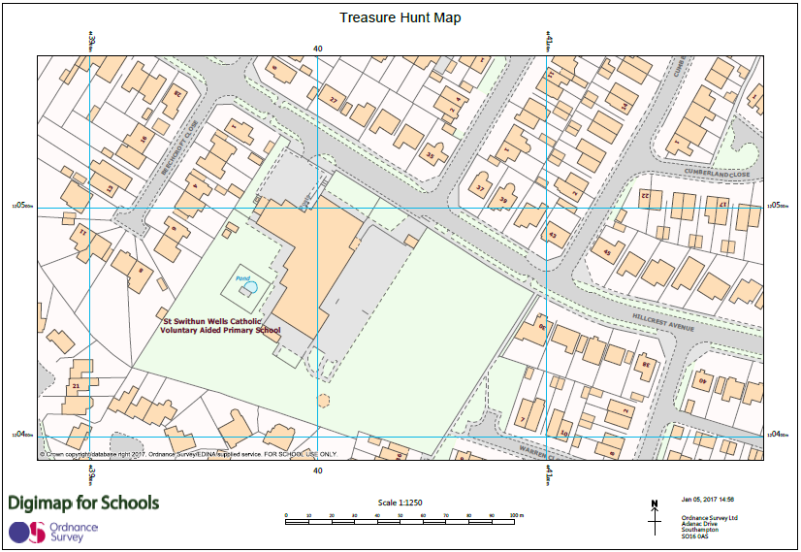

You can download map symbols from the OS website - https://www.ordnancesurvey.co.uk/docs/teaching-resources/25k-map-symbol-flashcards.pdf

Alternatively, rather than you creating the treasure hunt; why not let your pupils create it. Divide the class in to groups and allow them to create their own treasure hunt for the rest of the class to solve. This is great way to get you pupils thinking spatially and about the geography of the school.

2. Geographical walk in your area

I’m going to quote the curriculum for this example;

“use fieldwork to observe, measure, record and present the human and physical features in the local area using a range of methods including sketch maps, plans and graphs, and digital technologies.”

Within Digimap for Schools there are several tools that enable you and your pupils to add your own information to a map. This gives you the opportunity to use an ICT tool to plan and then present information about your locality.

Panning

Before you go on your walk, you can discuss with your class where you will be walking and work out how far you will be walking. Using the drawing tool, you can plot your route on the map and then using the measurement tool work out the distance. You can save the map ready for your pupils to add more information. (you could also try and calculate how long it’s likely to take. Some maths in a geography lesson!);

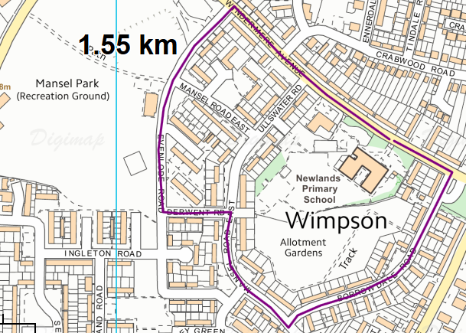

During the walk your pupils can gather information about the locality and take photos of key buildings and places of interest. Once back in the classroom your pupils can add text and pictures to your saved map. Once you have annotated the map, you can save it or print it.

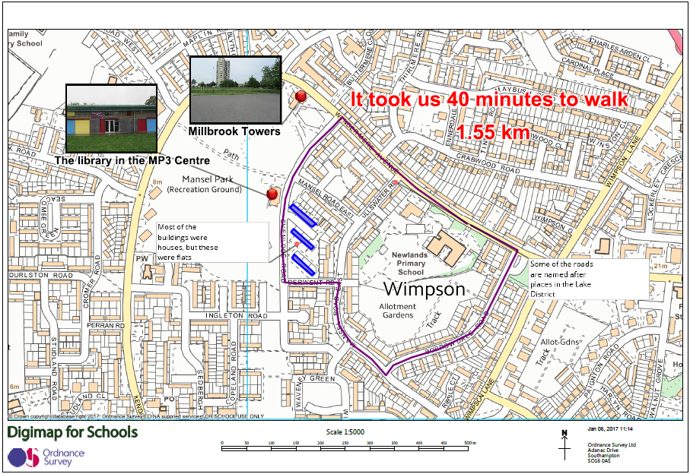

3. Land Use

Creating land use maps is a great way for pupils to explore their locality and look at the features around their school.

You can start by showing the area the pupils will explore and talk about the data you want them to collect. You can print out black and white maps that the pupils can take with them.

By using the annotation tools within Digimap for Schools, pupils can colour co-ordinate the buildings they record and you can add a simple key to frame the map. As an extra, you could also add photos of the some of the buildings.

Below is an example;

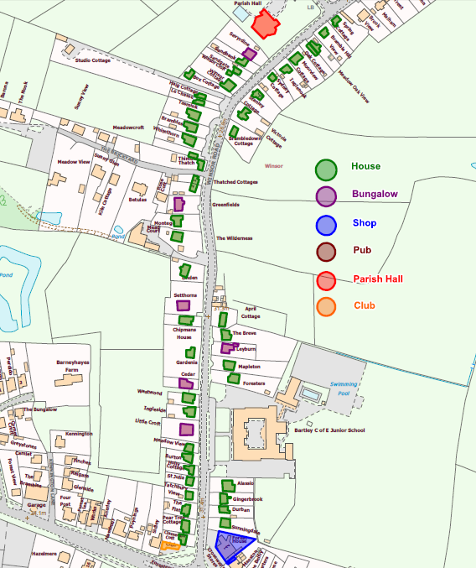

If you are fortunate enough to be in or able to visit a city centre, you can create some amazing looking land-use maps. The map below should look familiar to some of you, it’s the main shopping area in Southampton, including some photos;

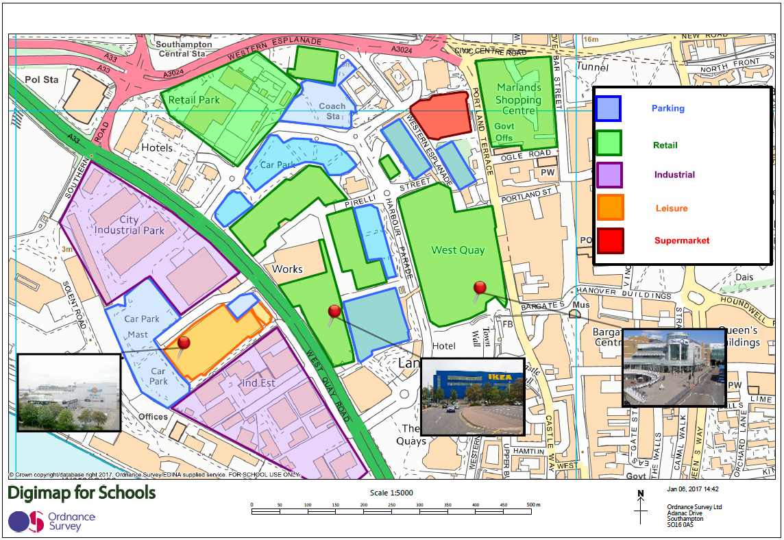

You can also view you annotated map as an aerial image!

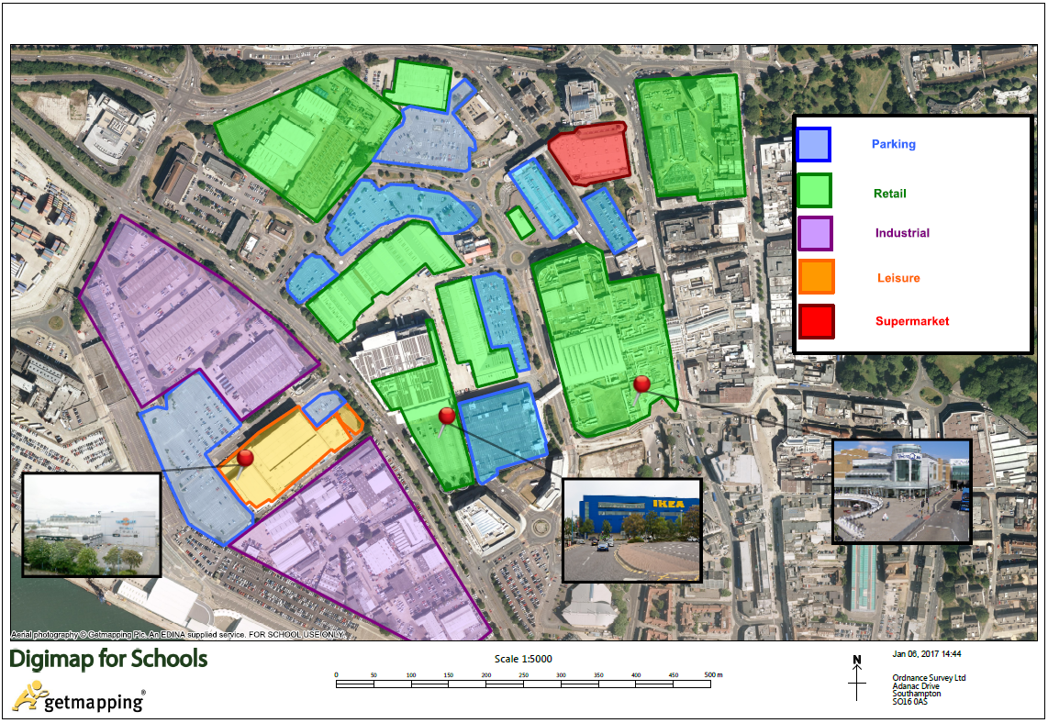

Using the aerial image, along with the mapping also gives you the option to do a virtual fieldtrip to another study area that may be miles away from you. If you want to add find some pictures toad try Geograph (http://www.geograph.org.uk/) It’s a free image library when you can search over 5 million images of the UK!
If you would like to find out more about Digimap for schools and how it can be used, take a look at the youtube channel - https://www.youtube.com/user/digimapforschools. If you are a user and would like to get some training for your staff, please send me an email darren.bailey@os.uk

