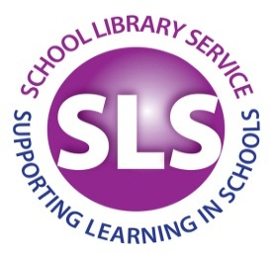

**KS1 & KS2 ATLASES**

**Collins First Atlas - Learn with maps (2015)**

£7.99 hardback/ £5.99 paperback

[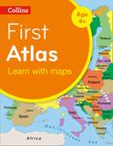](http://www.petranet.co.uk/images/covers/015/9780008101015.jpg)

Useful early concepts are clearly expressed, though would still benefit from adult input. An ideal curriculum support, this first atlas introduces the pupil to photographs and mapping of a younger local area. From this beginning the atlas gradually maps through regional, national, continental and world regions with global views of the wider world. Well worth having for KS1.

**Phillips Infant School Atlas (2015)**

£7.99 hardback

[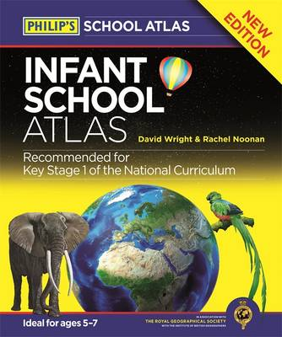](http://www.petranet.co.uk/images/covers/967/9781849073967.jpg)Clear, child-friendly maps are combined with fascinating photographs and facts about the world to provide essential geographical information for KS1. 'Balloons' link photos of real places to each map. Guidance is given at the beginning of the atlas on how to use the maps, encouraging the early development of map skills and knowledge of the world.

**Collins First Whiteboard Atlas (2014)**

£36 CD Rom

[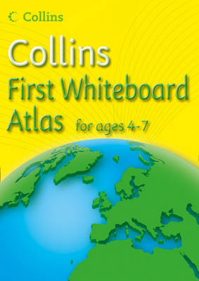](http://www.petranet.co.uk/images/covers/369/9780007500369.jpg)This interactive version provides a good introduction to photographs and mapping of the local area, together with regional, national continental and world mapping. Maps are supported with short informative sentences using basic geographical vocabulary. The pack includes printable blank outline maps of the continents, and the world to support classroom activities at KS1. *Also available at Primary level – not yet reviewed by SLS*.



**Collin’s Primary Atlas – Learn with Maps (2015)**

£7.99 paperback

[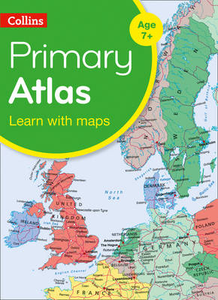](http://www.petranet.co.uk/images/covers/757/9780008146757.jpg)Good quality, up to date atlas, useful for classrooms or homework. The reference maps are informative, politically coloured, and easy to read with national capitals and major cities easily identifiable. The maps are supported with national flags and basic national statistics. Good for Upper KS1 and KS2.

**Phillip’s Junior School Atlas (Revised 2015)**

£8.99 hardback/ £7.99 paperback

[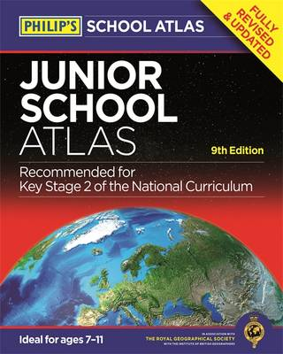](http://www.petranet.co.uk/images/covers/981/9781849073981.jpg)

A classic well-established basic title for KS2. This clearly presented, updated format is useful for schools & homework collections. Uses world thematic continental maps and includes topics such as the world's climate, vegetation, agriculture, energy sources, and environmental concerns, such as global warming.

**Collins Junior Atlas – Learn with Maps (2014)**

£8.99 paperback

[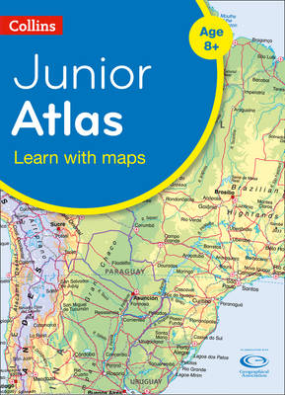](http://www.petranet.co.uk/images/covers/754/9780007524754.jpg)

A great deal of useful figures together with clear maps and diagrams make this an Ideal classroom resource. The atlas is organised into sections covering the UK, Europe, the World and Continents with larger scale maps of countries and regions popular for focus studies. Revised edition is due in February 2017.