

Geography Department

2023 Paper 3 Pre-release Issues Evaluation on tourism and economic development

**WORKBOOKLET**

Name…………………………………………Teacher………………………………

## What is the Issue Evaluation?

This pre-release workbooklet helps you prepare for the first half of the Paper 3 exam on 16th June which is an issues evaluation. This year it is about tourism and the proposed development of a cruise ship terminal in the Cayman Islands in the Caribbean.

There are 37 marks (including SPaG) available for this section - these marks make up approximately 14% of your final grade.

It’s a 7-page booklet with lots of sources to examine a particular issue such as graphs and photos. The aim of the issue evaluation is to assess your critical thinking and problem-solving skills.

What will you need to do to prepare:

* Get familiar with all the figures and information in the resource booklet
* Learn about the issue of the proposed cruise terminal in the Cayman Islands
* Consider the views of stakeholders both for and against the terminal
* Evaluate and argue the problems and benefits of the issue

## Pre-Release Materials in AQA GCSE Geography Exam

In the exam you will need to answer a range of questions about the issue. You will have about 35-40 minutes for this section of the exam. (The 2nd half is all about fieldwork)

There will be a series of short skills questions (2-3 marks) followed by 6 mark extended questions and then a final 9-mark question which asks you to evaluate an answer to an issue i.e. **Why should the Cayman Islands build a new cruise ship marine terminal in George Town?**

You will be asked whether you agree or disagree with a statement and then you will be expected to explain your answer**. It does not matter whether you agree or disagree what matters is how you justify your answer using evidence from the materials in the resource booklet and your own knowledge.**

Your answer for the 9-mark questions will also be awarded marks for spelling, punctuation and grammar.

## Can you take your pre-release booklet into the AQA GCSE Geography exam?

You cannot take your booklet and notes into the examination room, but you will be given a new copy of the booklet with the question paper.

That’s why you have your own copy now, to get used to it. To know where key information is they you will need like how many jobs are created by tourists in the Cayman Islands (it’s 5000!)

**Figure 1**

1. What are the three development goals that tourism contributes to?
2. What is the income distribution effect of tourism? (1 mark)

___________________________________________________________________________

___________________________________________________________________________

1. Using figure 1 identify 3 ways that tourism helps development (3 marks)


5. Using the graph and figures on page 2
   1. Which region sends the largest number of international tourists? _______________
   2. Which region sends the least number of international tourists? _________________
   3. Why is this? ______________________________________________________________

__________________________________________________________________________________________________________________________________________________

* 1. Describe the distribution of the top 20 destinations most reliant on tourism for their income:

_________________________________________________________________________

_________________________________________________________________________

_________________________________________________________________________

_________________________________________________________________________

1. Using the Graph on page 3 in 2018 approximately what percentage of international tourist arrivals come from Europe? (2 marks)

Show your working:

1. Complete the graph below for 2019 using the information in figure 1 – the growth of cruise tourism

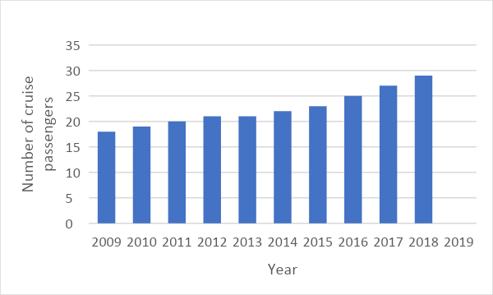

1. Describe the trend in the number of arrivals from cruise passengers

_________________________________________________________________________

_________________________________________________________________________

_________________________________________________________________________

1. Describe the location of the Caymen Islands (2 marks)

_________________________________________________________________________

_________________________________________________________________________

_________________________________________________________________________

1. Calculate the percentage increase in tourism between 2009 and 2018 __________________
2. The Caribbean is the most popular destination for cruises but what are the other two up and coming areas? __________________________________
3. How many ocean-going cruise ships have been commissioned to be built by 2025?_________
4. Explain 2 ways in which the tourism minister suggests that tourism development can improve facilities for local people? _______________________________________________________­­­­____________________

_________________________________________________________________________

_________________________________________________________________________

_________________________________________________________________________

1. Fill in the missing words:
   1. For every one dollar of visitor spending, an additional ______ is generated by ____________visitors and ________ by cruise ship visitors.
   2. For every ______________ invested in the ___________ industry, _____ jobs are created.
   3. Every ________ room creates at least _____ job.
   4. The marine tourism industry generates _________ million jobs.
   5. _____________ revenue going back into the local economy; _______________ 95%, All inclusive package tours _______
   6. Cruise ships in the _________________ are estimated to produce more than ____________ tonnes of wastewater per year.
2. On your booklet make a key and categorise the statements into positive and negative
3. Why is tourism to the Cayman Islands (3 marks)

_________________________________________________________________________________________________________________________________________________________________________________________________________________________________________________________________________________________________________________________________________________________________________________________________________________________________________________________________________________­­­­­­­­­­­­­­­­­______________________________________________________________________________

1. Outline one positive and one negative of tourism in the Caribbean (2 marks)

_____________________________________________________________________________________________________________________________________________________________________________________________________________________________________________

_______________________________________________________________________­­­­­________

**Figure 2 – A new cruise ship terminal and port for the Cayman Islands**

1. Calculate the percentage increase in cruise passengers between 1998 and 2018 ___________
2. Using the photograph at the top of page 2 explain would visitors have a **poor impression** of the port.
3. When was the new port development first proposed? _____________
4. What is the aim of the multiuse redevelopment project?



1. How do the passengers get to shore from the cruise liners? What is the problem with this?

_______________________________________________________________________________

______________________________________________________________________________________________________________________________________________________________

1. Using figure 2 outline why a new cruise ship terminal is required in the Caymen Islands (2 marks)

_______________________________________________________________________________________________________________________________________________________________________________________________________________________________________________________________ __________________________________________________________________________________________________________________________________________________________________________

1. How many local people rely on cruise tourism for employment?_____________
2. Explain the benefits of the proposed cruise port on the Cayman Islands (4 marks)

_________________________________________________________________________________________________________________________________________________________________________________________________________________________________________________________________________________________________________________________________________________________________________________________________________________________________________________________________________________________________________________________________________________________________________

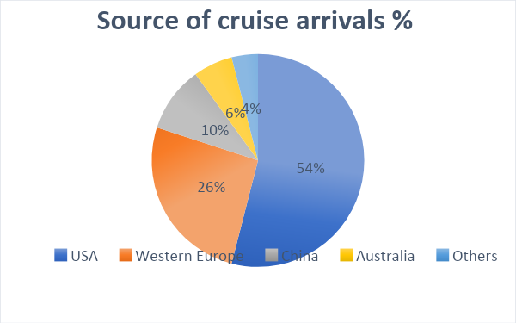

1. Which country sends the largest amount of cruise arrivals? ___________
2. What do environmentalists say will happen if the development goes ahead:

___________________________________________________________________________________________________________________________________________________________________________________________________________________________________________________

Using the graph of **sunshine hours and temperature** on page 5:

1. Which months have the highest number of sunshine hours? ___________________
2. What is the average temperature in December? _______________
3. What is the range of sunshine hours in the Cayman Islands? ____________________
4. What is the temperature range in the Cayman Islands? ___________
5. What attractions should you go and see whilst in the Cayman Islands? _________________
6. What is the modal sunshine hours on the Cayman Islands (1 mark) ­­­­___________________

**Figure 3 pages 6: different views about the development**

1. How will the new development support the multiplier effect? _________________________

___________________________________________________________________________­__________

_____________________________________________________________________________________

_____________________________________________________________________________________

1. State 3 features of the George Town Revitalisation Initiative:



1. Describe 3 actions the government will take to reduce environmental effects.
   * _________________________________________________________________
   * _________________________________________________________________
   * _________________________________________________________________
2. Using figure 3 page 7 complete the table below with stakeholder quotes for and against the development- jot down the category that the stakeholder comes from eg environmentalist, business person etc

|  |  |
| --- | --- |
| For the proposed development | Against the proposed development |
|  |  |

1. Devise a key and categorise the table below into positives and negatives of the development. Then social, economic and environmental

|  |  |  |  |
| --- | --- | --- | --- |
| Enable larger ships to visit the islands and disembark directly on to shore | The daily spending per person for cruise passengers is 55% lower than long stay visitors | While the number of visitors has consistently increased, per visitor spending has decreased over the last 30 years. | Cruise passengers may choose to stay on the cruise ship and not spend any money in the visiting country. |
| Cruise passengers only usually stay for one day. | Fears for the future of cruise liners because as they get larger they need different docking access. | Allow more cruise passengers to visit the islands. | 5000 local people rely on cruise tourism and this number would increase significantly |
| The revitalisation initiative will create living and business space in new and restored buildings with cafes and restaurants for people to enjoy food and entertainment. | Damage to the environment will discourage many stay-over visitors who come because of the pristine and unique environment. | Stunning natural environment has something for everyone, from the award winning seven-mile beach to the iguanas of Queen Elizabeth 11 Botanic Park | 15 acres of coral reef, home to critically endangered turtles could be destroyed to make way for 2 cruise ship docks. Permanent loss of a world-class coral reef. |
| Less money in the community means fewer job opportunities, leaving workers struggling to support their families. | New cruise ship and port facility will create hundreds of new jobs for both skilled and unskilled people and improve their quality of life. | George town will be regenerated encouraging new industry, leisure and cultural opportunities to visitors and local people. | 22 acres of the seabed will be dredged and the silt sedimentation will turn the sea to murky white |
| A new pedestrianised area will have improved lighting, seating and green spaces and improved access for cyclists. | Reduction of visitors and loss of income from water sports and diving activities. | Separate cruise ship and cargo traffic creating a nice experience for passengers. | Port development will damage coral reefs and remove snorkelling and diving sites |
| Increased pedestrian and vehicle traffic in George Town | Reduced small boat traffic congestion and risk of marine accidents | Loss of income for small boat operators | If there are fewer cruise arrivals then fewer people take tours, visit attractions and spend money. |
| Long stay tourists stay for an average of 8 days. | RSPB said it will cause long term damage to the ecosystem and a loss of wildlife | It is a unique marine environment; that is why it attracts thousands of visitors for diving and snorkelling holidays | Cayman has always catered for long-stay visitors but has ignored the cruise market, this development will bring wealthy visitors all year round. |

**The 9-marker (+3 SPaG)**