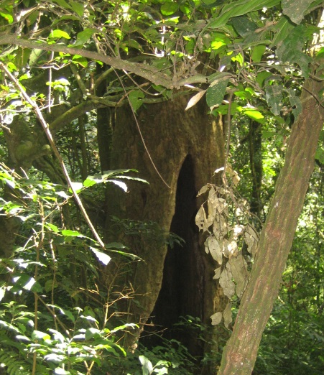
Climate zones, biomes and vegetation belts
KS2 physical geography
▪ describe and understand key aspects of:
▪ physical geography, including: climate zones, biomes and vegetation belts.
Skills

- Use a range of maps, atlases, images, globes and digital mapping
- Locate countries and describe features studied in the KS2 NC
- Use compass directions: N, NE, E, SE, S, SW, W, NW to follow and give directions to build knowledge of the UK and the wider world
- Accurately use six figure grid references on an map OS map
- Draw maps, sketches and plans with accurate symbols, keys and scale
- Ask geographical questions about places and environments to carry out investigations and can explain opinions from a range of view points

Book suggestions

77.34 Rainforests Anita Ganeri
577.54 Deserts Around the World Jen Green
PFOR Antarctica Helen Gowcher
CF Under the Weather Tony Bradman (edited by)
CF The Jaguar Trials Ruth Eastham (upper KS2)

Key words to support planning

Atmospheric pressure, biodiversity, biome, boreal forest/Taiga, climate, confierous forest, continent, continental climate, deciduous forest, desert, distribution, ecosystem, environment, equator, equatorial climate, flora, forest, global, humidity, latitude, location, longitude, maritime climate, ocean, pattern, precipitation, rainforest, savanna, season, soil, sun, temperate, temperature, tundra, vegatation belt, weather, wind.

Antarctic Circle, Arctic Circle, continent, country, equator, Europe, latitide, longitude, North America, Northern hemisphere, ocean, South America, Southern hemisphere, time zones, Tropic of Cancer, Tropic of Capricorn

Fieldwork

- Link local observations to wider world to identify patterns
- Use camera and locate photos on a map
- Draw sketch map showing human and physical features
- Devise and answer questions using geographical vocabulary
- Measure and record primary data using a range of appropriate images
- Justify and evaluate data collection methods
- Independently present data and findings using maps, graphs and digital technologies to show clear enquiry route
- Conclude fieldwork investigations with explanations and evidence

Activity | Learning
Do we live in a biome? | Chn plan their own fieldwork to prove which biome they live in and collect evidence to back it up
What is the character of our biome? | Chn explore ecosystems in their local area to explore the character of their place. Visit a small woodland area, a river, a pond, a field and other nature areas

Medium term planning ideas

1 | Who lives where?  Show pictures of animals from around the world and ask chn to guess where they live. Introduce and play with key vocab for chn to use to be accurate geographers. Card match: picture of an animal; description of the vegetation; and a description on the climate. Tundra, deciduous forest, coniferous forest, savanna grasslands,desert, rainforest. Chn match them into groups of three and then locate them on a map of biomes
2 | Can we find the belts of the earth?  Introduce latitude and explore the latitudes of each biome. Horizontal jigsaw of a map of the earth. Chn explore the ‘mirror’ effect of the sun along the equator in the northern and southern hemisphere.
3 | Do we live in a biome?  Chn predict and prove which ecosystem we live in. Design their own fieldwork to carry out around school and the local area.
4 | Does our climate match our biome character?  Using weather information (e.g. http://www.metoffice.gov.uk/public/weather/climate/gcp1c5hp4) to create a biome character including seasonal differences, vegatation and animal adaptations.
5 | Is a (specific desert animal)…… living in the right biome?  Use climate information and maps for chn to investigate whether the specific animal is living in the right biome based on their adaptations.
6 | Is a (specific rainforest animal)…… living in the right biome?  Use climate information and maps for chn to investigate whether the specific animal is living in the right biome based on their adaptations.
7 | Is a (specific coniferous forest animal)…… living in the right biome?  Use climate information and maps for chn to investigate whether the specific animal is living in the right biome based on their adaptations.
8 | Is a (specific tundra/polar region animal)…… living in the right biome?  Use climate information and maps for chn to investigate whether the specific animal is living in the right biome based on their adaptations.
9 | Long way down  Chn start from the north pole and pick a route to the south pole travelling through climates and biomes. Their presentation should reflect the changes that take place to the climate and the vegetation.

