The Great Outdoors: Fieldwork in Primary Geography

‘The environment is at the heart of everything we do and we believe being outside in different habitats offers exciting challenges that students may not otherwise get the opportunity to experience. The stunning locations visited may be on site at our centres, or a short journey away.’
The Field Studies Council

Fieldwork is a vital component of our primary geography. It gives children the skills that can be difficult to learn in the classroom. As well as geographical skills, fieldwork can offer the social benefits of spending time together cooperatively and develop affective learning. Fieldwork is valuable for the teachers and practitioners too because it can be another time to form relationships with children in the busy timetable of daily teaching and learning. This can be a time for shared experiences and extended conversations. This can lead to higher level thinking and talking.

Why must we use fieldwork?
- children can develop their investigation and decision making skills
- children will use maps and new technologies such as GIS
- it is a requirement of the key stage 1 and 2 curriculum
- it can be challenging and allow children to take safe ‘risks’
- children will experience the environment beyond the classroom
- it teaches children respect for their environment
- it will develop children’s understanding and knowledge about the world they live in

Fieldwork in my Year 1 class
My class had the topic of ‘Out and About’ and I wanted to use fieldwork techniques to teach them about forests as we are lucky enough to have wonderful woodland in our school grounds. This could be taught in a local wooded area. The learning was inspired by the book ‘The Gruffalo’.
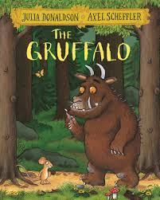

Activity | Learning
What is a forest like? | Begin with stories based in forests: what is is like in the story? Gather key words about what is there eg trees, plants, mud, space, water.  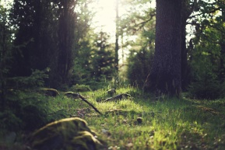
What human and physical features can we identify? | Use an ariel photo and mapping of a forest: Can we find areas where trees are planted? Are trees all the same colour, what are the differences between the tree and covered areas? Find trees of different ages, identify some trees, what other features can we see on the areial photo eg roads, open spaces?  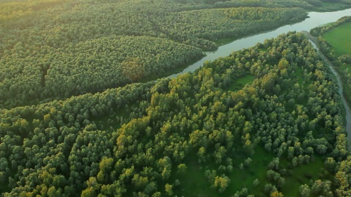  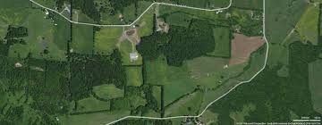
Look around: what can you see? | Which things are physical/natural features and which are man-made/human features? Place pictures/words in the woods to match the feature eg Person picture and mountain picture.  Using a map of the forest: follow the route. Add the human/physical features to the map with a key.  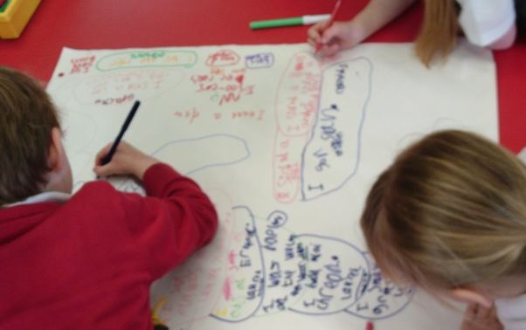
Create a map for a ‘mouse’ eg in the Gruffalo. Use a metre length of string. Children to choose where to lay the string to create an adventurous route for the mouse. Eg a puddle could become a stream, rock a mountain.
Owl to have a route through the trees to talk about the upper layers of the forest.

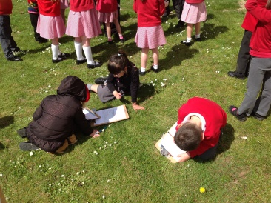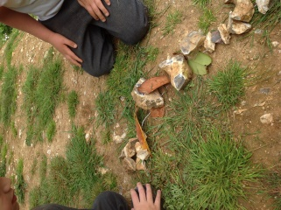

What types of trees are there?  (Cross-curricular links with Science) | Vegetation: Can we identify the trees, plants? Descriptions using our senses.  Trees: provide homes and food for animals and birds. What kind of wildlife live here? Are there any clues?  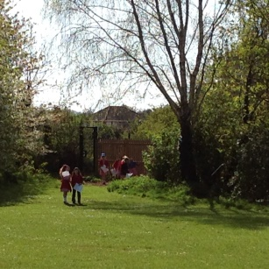
Making maps and compass directions. | Find the compass on the map. Play games in the woods to teach compass directions and using a compass. 8 point compass directions.  Make a map using sticks the children find in the woods. Draw the maps they make using a key and symbols.  